CS-BFD USERS MANUAL

Connect Systems Inc
5321 Derry Ave., Suite B
Agoura Hills, CA 91301

Copyright 2019
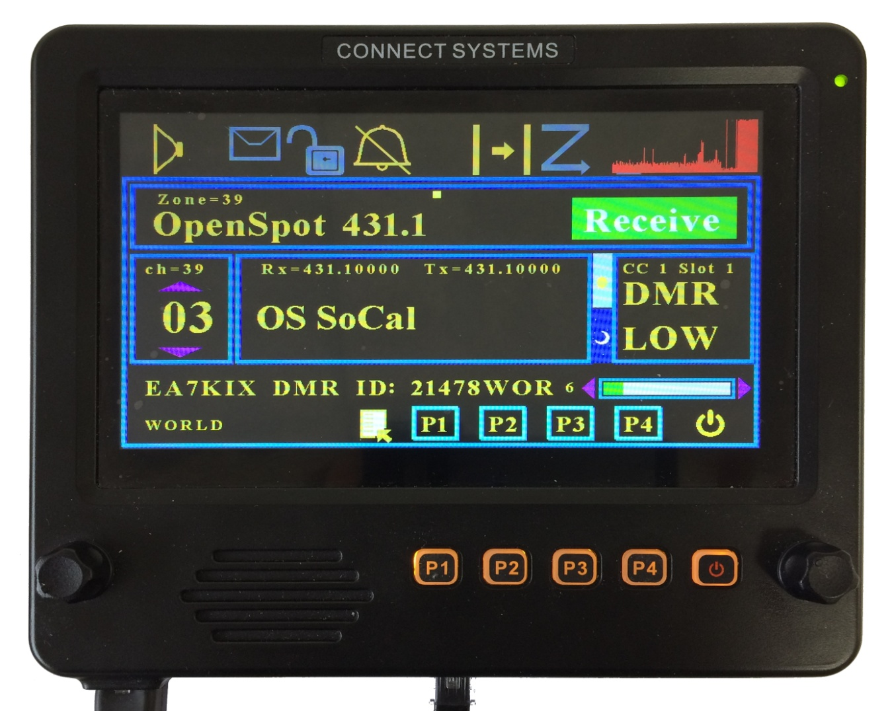

INTRODUCTION

The CS-BFD is the first in a set of products that allows the HAM to increase the functionality of their existing radios. The firmware and the hardware design will be available to allow the resourceful HAM to modify the product to exactly meet their needs and desires as well as the ability to be modified to work with other radios.

At the time this manual was written, this product works with the CS800D, CS800, C801, and the FT857D. We are working with other radios but it is too soon to give a schedule of when we expect to have those projects completed.

MECHANICAL PARAMETERS

Weight: 25 Ounces

Dimensions: 7 ¾ x 6 ¾ x 1 ¼

Screen Diagonal Size: 7”

Active Screen Size 6 x 3 ½

JUMPERS
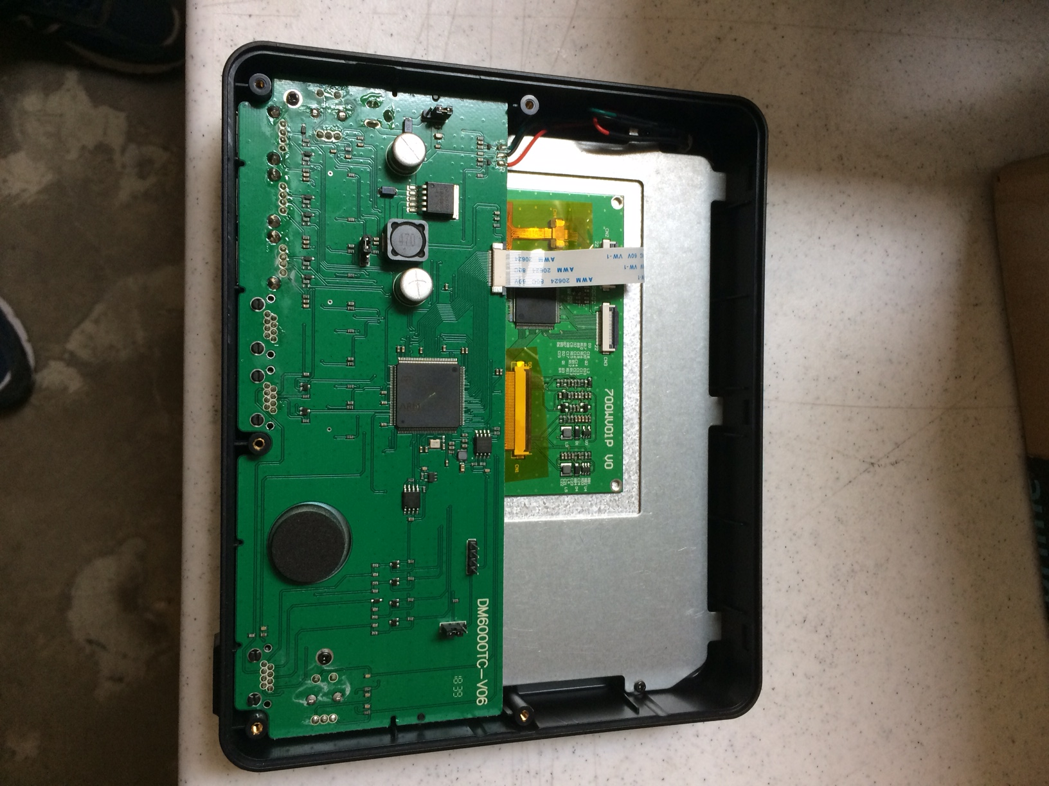
JP3
JP2
JP4
JP1

JP1 is used to determine the source of its power. If the jumper is between the center pin and the pin closest to the top of the display, then the power is derived from the radio. If the jumper is between the center pin and the bottom of the display, then the power is derived from an external power supply.

JP2 is a four pin jumper block and is used as the connector for attaching a debug pod to allow the programmer to debug the display.

JP3 is used for setting the microprocessor to boot mode to allow the user to load the firmware in case the display gets bricked. If the jumper is between the center pin and the pin closest to the four pin jumper, then the microprocessor is in boot mode. If the jumper is between the center pin and the bottom of the display, then the microprocessor is in normal mode.

JP4 is used for enabling the backlight for P1 - P4 and the power key. If the jumper is between the middle pin and the pin closest to JP1 then the backlight for those keys are always on. If the jumper is absent or the jumper is between the center pin and the pin closest to JP2, then the backlight for those keys are always off. The backlight for those keys take a significant amount of power.

REAR OF THE CS-BFD

Notice the four holes on the back are made to fit any AMPS compatible device. That will allow you to buy compatible mounting devices from RAM MOUNTS and others

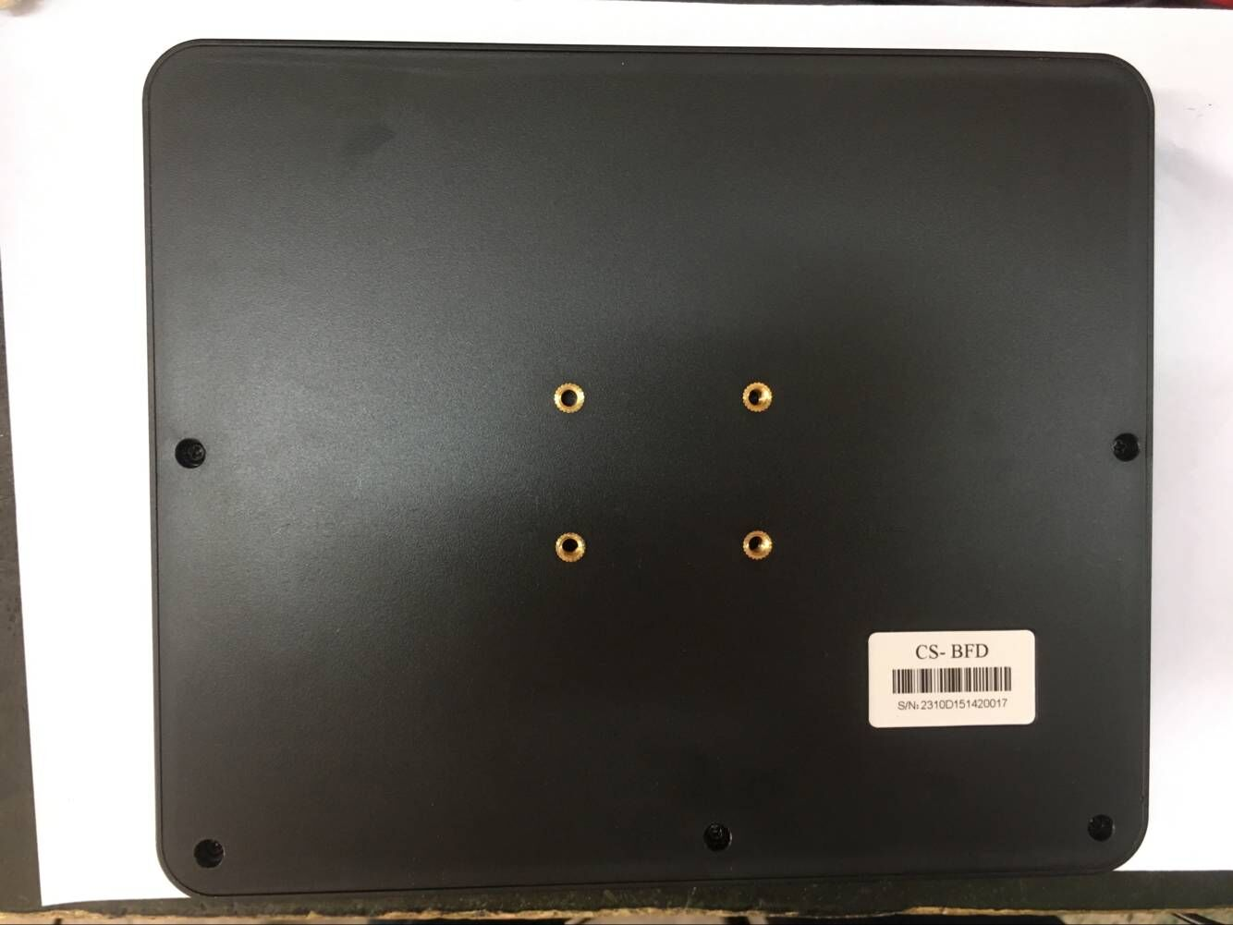

UPDATING THE FIRMWARE

We are going to continue updating this product for a long time to add new features, fix problems, and add the ability to add new radios. Updating the firmware takes just a few seconds after the Dfuse program is installed.

Updating can normally be done by pressing the P1 and P4 keys at the same time while power is applied. However, if the unit is bricked, it is necessary to open the back of the case, insert a jumper in a jumper block, and then turn on the power.

Then you load the new file in the Dfuse program, and press the button to start the update.

We provided a separate application note that goes in exquisite details on how to perform this simple task.

CS800D KEYS VERSES CS-BFD KEY

CS800D CS-BFD

P1 P1
P2 P2
P3 P3
P4 P4
P5 LEFT ROTARY SWITCH CW
P6 LEFT ROTARY SWITCH CCW
P7 PRESS LEFT ROTARY SWITCH
P8 RIGHT ROTARY SWITCH

Note: There is no equivalent of P5 and P6 long press. It is suggested to use the microphone buttons for that purpose.

ICONS DESCRIPTION

 | Digital Monitor
 | Message
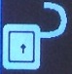 | Encryption
 | Alert Tone
 | Call Type
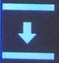 | Talk Around
 | Scan

ICONS DESCRIPTION

 | GPS
 | RSSI
 | Last Called

Setting the parameters back to factory default

If you have problems reading the screen or you want to erase the favorites you already put in, pressing the P3 key as you turn on the power will set everything back to factory default.

USING THE CS-BFD WITH YOUR CS800D, CS800, OR CS801

(1) Plug a CAT 5 or CAT 6 cable between the Primary Port of the CS-BFD and your display connector on your radio.

(2) Plug the microphone that came with the radio into the microphone port of the CS-BFD. If you do not want to use the one that came with the radio, you can use a Kenwood MC-59 microphone or buy another microphone from Connect Systems.

(3) Provide power to your radio.

(4) Press the power switch on the CS-BFD for about six seconds. In a few seconds the display will light up and you are now ready to use the CS-BFD. If the radio turns off after you released the power switch, you did not press the power switch long enough. You should press it long enough to hear the turn on tone sequence. If you press the power button and then release it before you hear the tone, then the panel might look like its working but seems to be locked up. The display is not locked up. it is the radio. The radio is supplying power to the display but is actually off. If you continue to press the power button under those circumstances, then the radio will generate the tones and you are ready to go.

OPERATION OF THE CS-BFD

When you first turn on the CS-BFD, you will get the following splash screen:

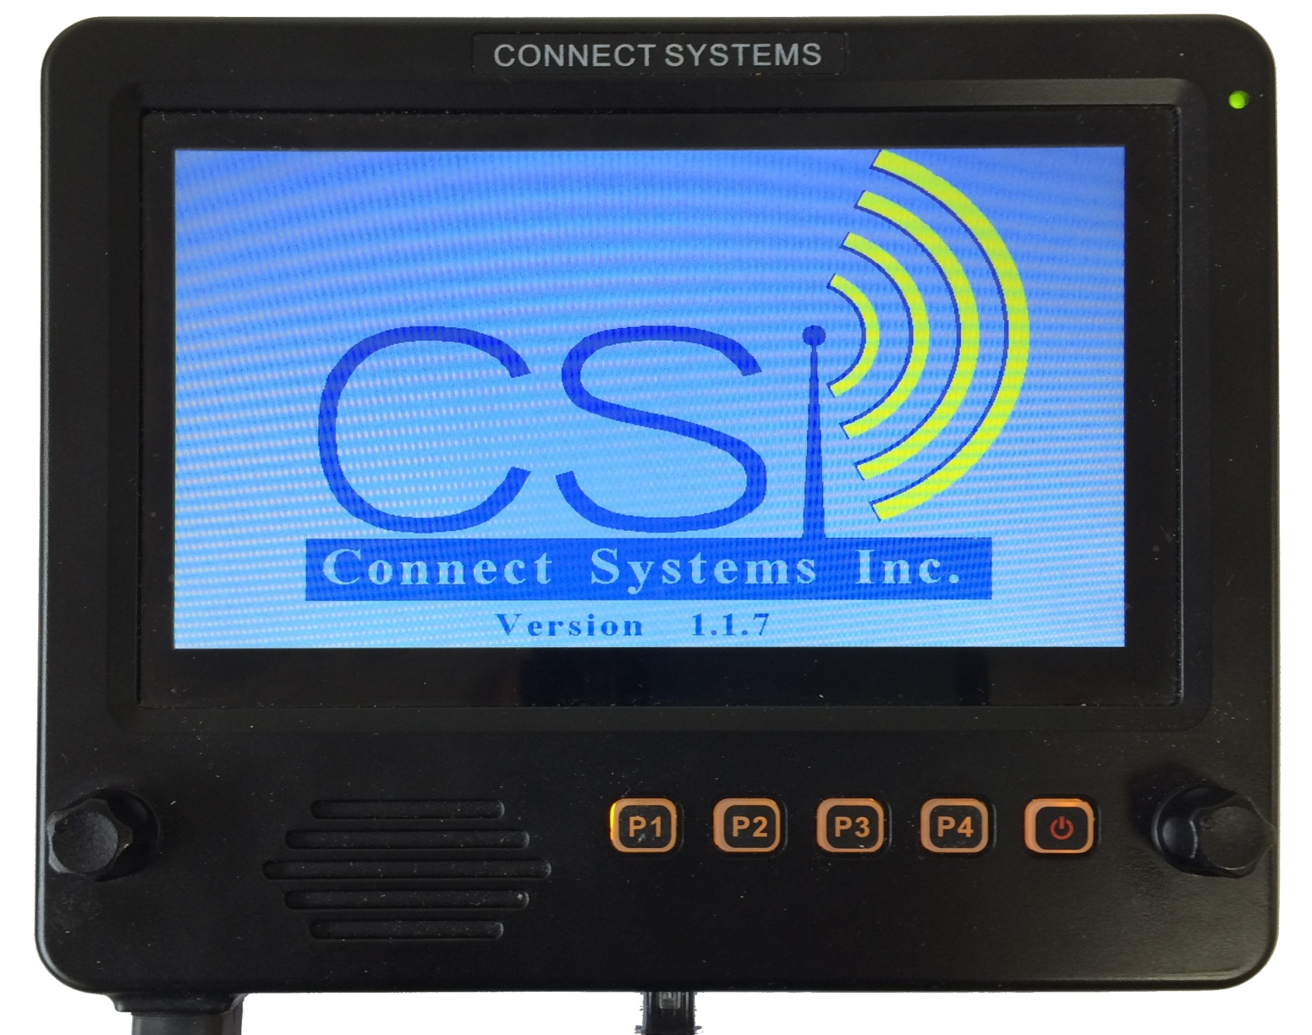

Followed by this screen

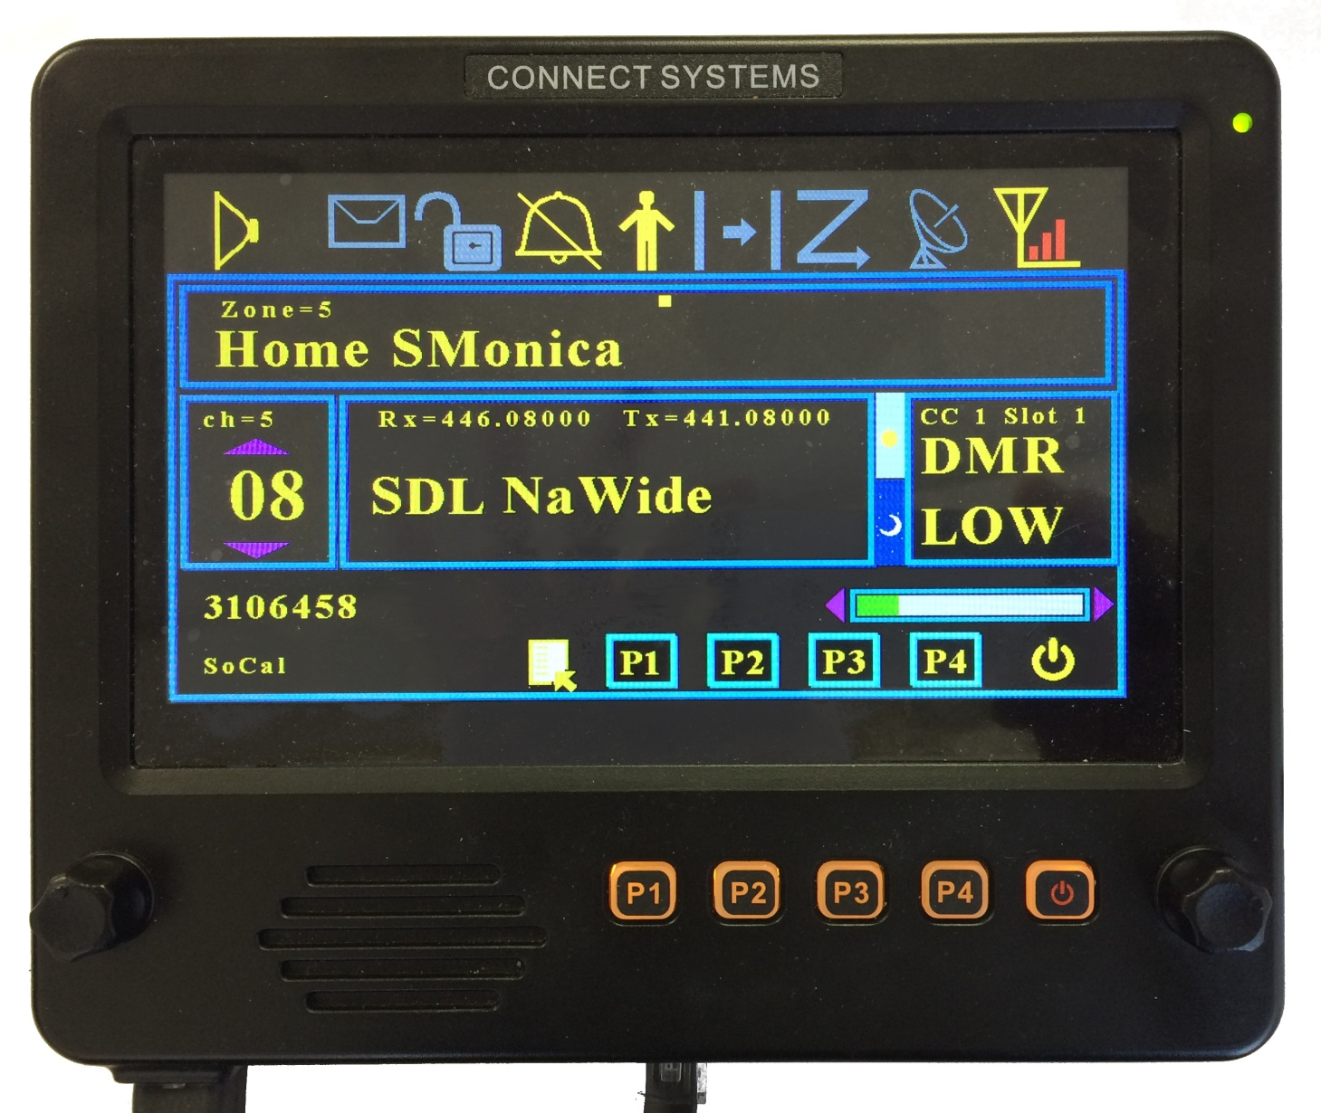

By comparison, if you have the standard CS-800D with the small screen, you will get the following when you first turn on

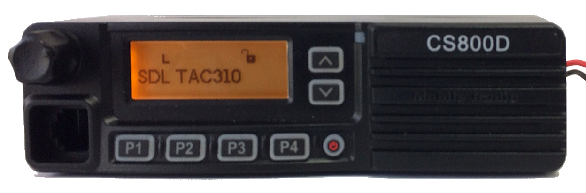

If you press the PTT, then you will get the following screen:

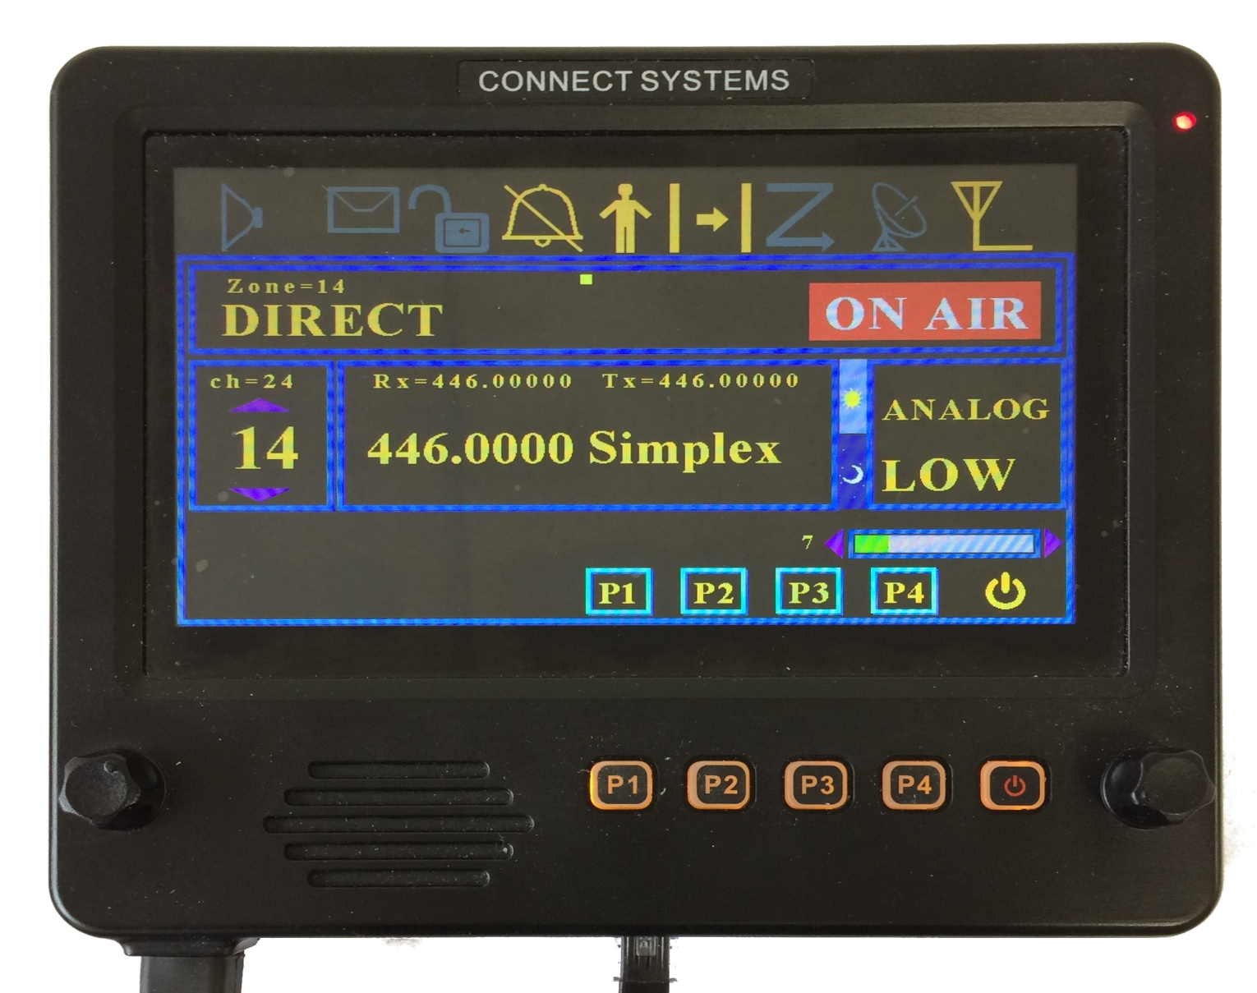

If you are receiving a QSO you get the following screen:

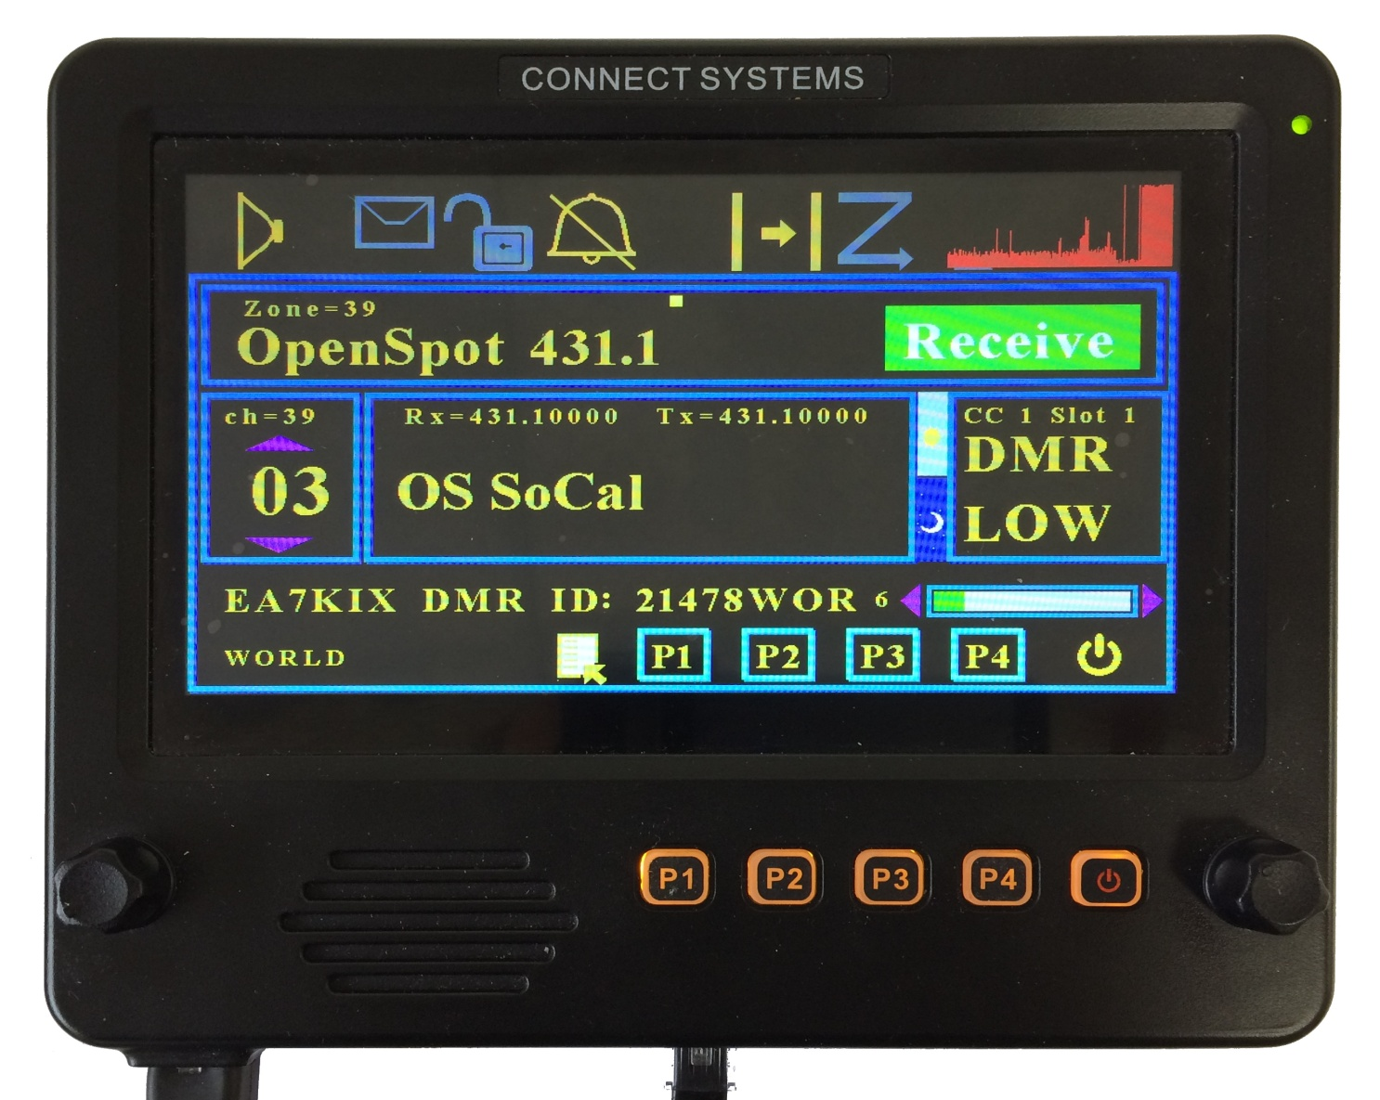

If you want to see the last called, you press the ICON to the left of the P1 soft key and you get:

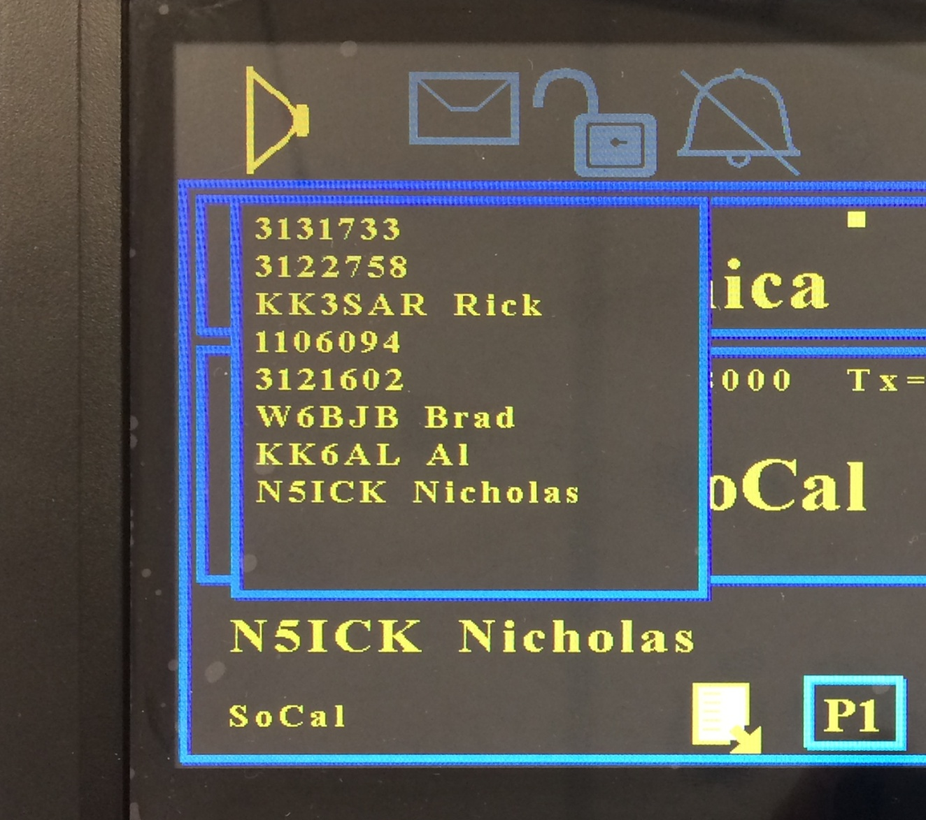

ADVANCED FEATURES

Pressing the rotary switch on the right will bring up the following screen:

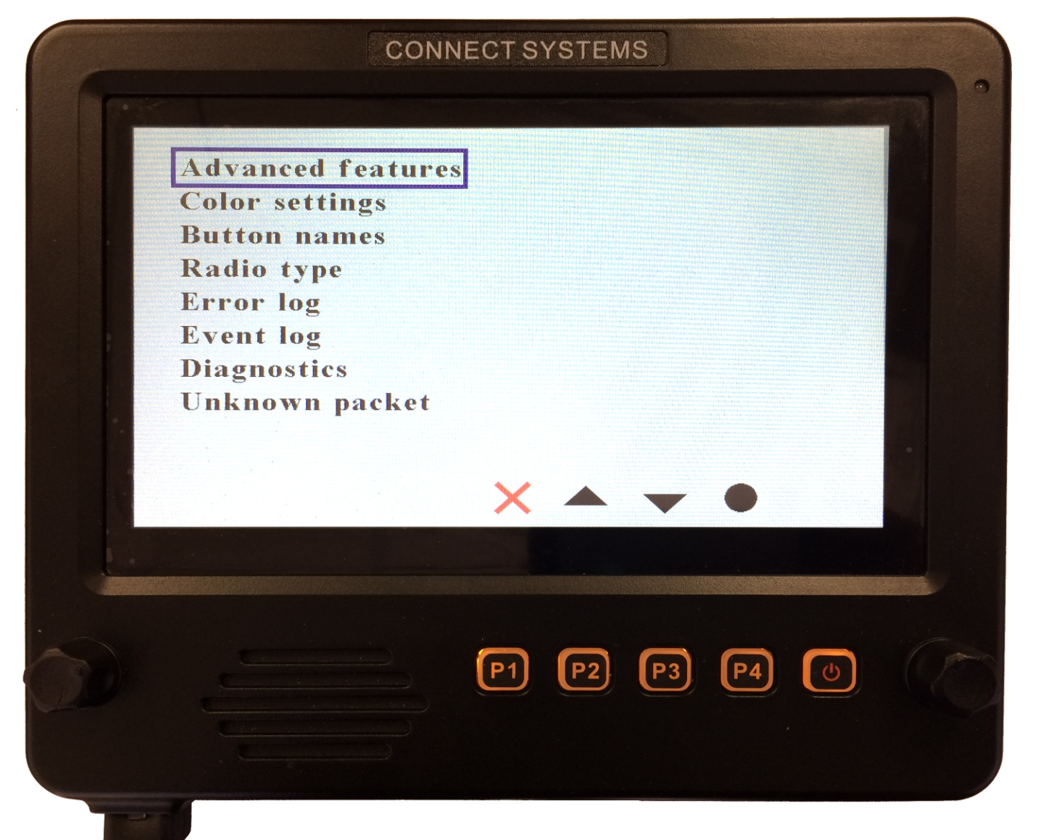

The up and down arrow on the touch screen or P2 or P3 will select which feature you want to select. The solid circle on the touch screen or P4 will select that feature that is highlighted. To exit from this menu select press the Red X on the touch screen or P1.

Advanced Features

Pressing the Advanced Features menu gives the following screen:

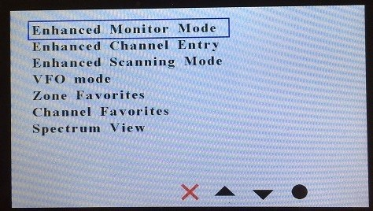

Advanced Features

1. Enhanced Monitor Mode
Your display will show graphically the different groups being received and the length of time that group has been active.
2. Enhanced Channel Entry
From a single screen, able to enter all the parameters necessary for creating a temporary channel.
3. Enhanced Scanning Mode
Scans between two frequencies. This is in contrast to the normal scanning mode that only allows you to only scan preprogrammed channels.
4. VFO Mode
Able to change frequencies by twisting the button on the panel.
5. Zone Favorites
Able to select one of your 16 favorites zones. There is a shortcut using the touch panel to get directly to this screen from the normal standby screen.
6. Channel Favorites
Able to select one of your 16 favorites channels. There is a shortcut using the touch panel to get directly to this screen from the normal standby screen.
7. Spectrum View
Spectrum Analyzer to determine the radio activity over a range of frequencies.

Details of these above features will be described later.

Color settings
The Color setting will allow you to change the default colors on the different screens. The program assumes a fixed palette of colors. If you do not like the selection it is possible to completely redefine the color selection in the palette. In case you made a mistake, it is possible to set the display back to the default colors.

Button names
The default settings on the screen for the four buttons is P1 through P4. This screen will allow you to change the default settings to something that is more meaningful. This feature is not supported in the first release.

Radio Type
Currently allows you to select the following:
1. CS800D/CS800/CS801 on the primary port
2. FT857D on the primary port
3. CS800D/CS800/CS801 on the primary port and FT857D on the UART port.

Radio type 3 is not supported in the current releases.

Error Log
There are a significant number of traps in the firmware to look for problems that should never happen. The error log records the information and allows the user to see those. The customer should take a photo of those errors and send it to the factory to allow us to make the firmware better.

Event Log
This records the major events in the system such as pressing a key and receiving packets from the radio.

Diagnostics
The hardware can be tested with this diagnostic. It checks for various things such as the proper operation of the touch screen, switches, and various components inside the unit.

Unknown Packet
The design of this product is based on reverse engineering the operation of the radio attached to the CS-BFD. Different packets are sent from the radio dependent on the keys the user presses and what is happening with the radio. It is possible we never seen a particular event happen and that event gives us a packet we have never seen before. If that happens we capture and store the packet and that packet will be displayed in this screen. If that happens we will ask you to take a photo of the unknown packet as well as the event log so we could hopefully reproduce it and fix the problem, so it never happens again.

COLOR SETTING

If the color setting is selected, you will get a screen as shown below. You can now select what feature of the screen you want to change. As an example, I will show how to change the text to white and the text background to black. Start by pressing the circle with your finger or the P4 key.

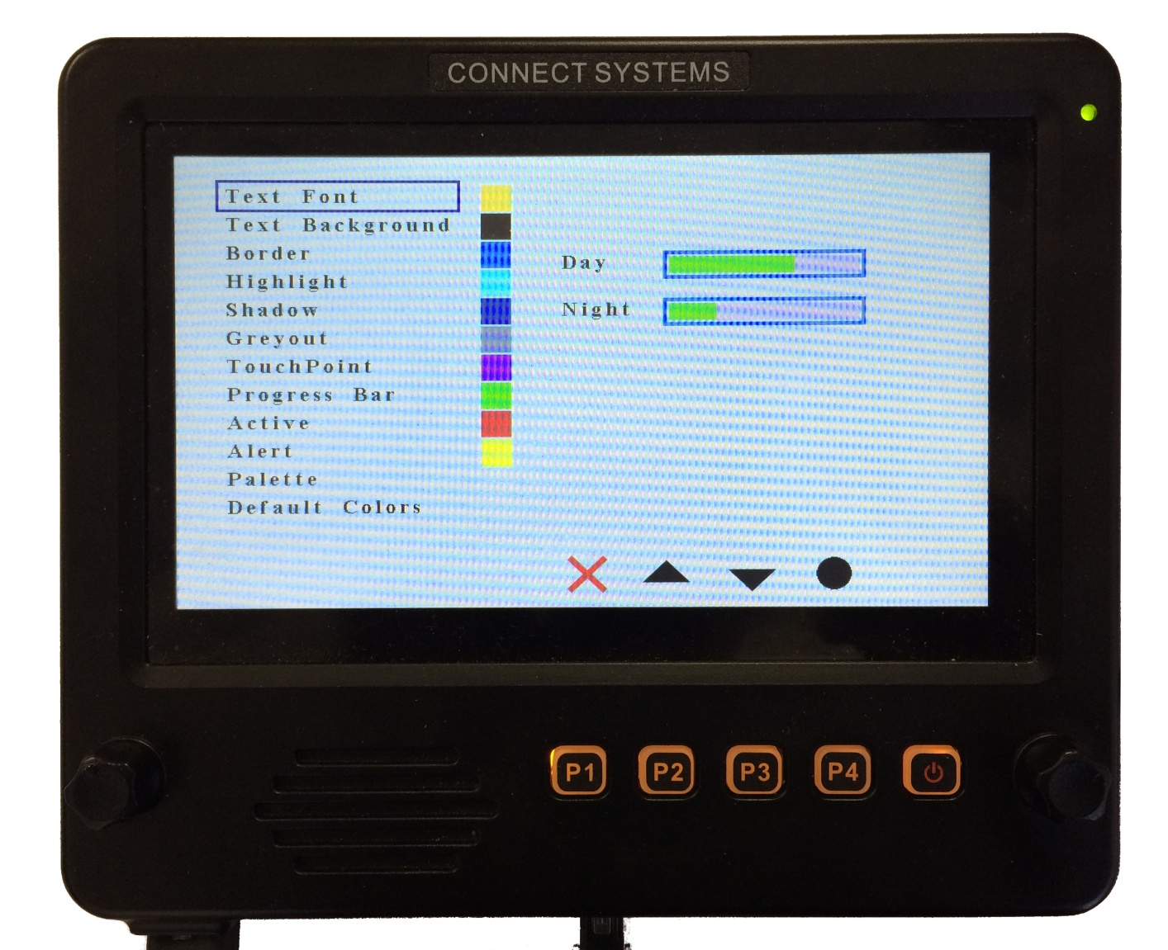

You get the screen as shown below. Now use the left arrow of P2 or the right arrow or P3 to select the color of the text font. In this case we want to select white. Notice that when the arrow key is moved to the left or right, the active color is show with a blue outline When you get the appropriate color, press the circle with your finger or the P4 key.

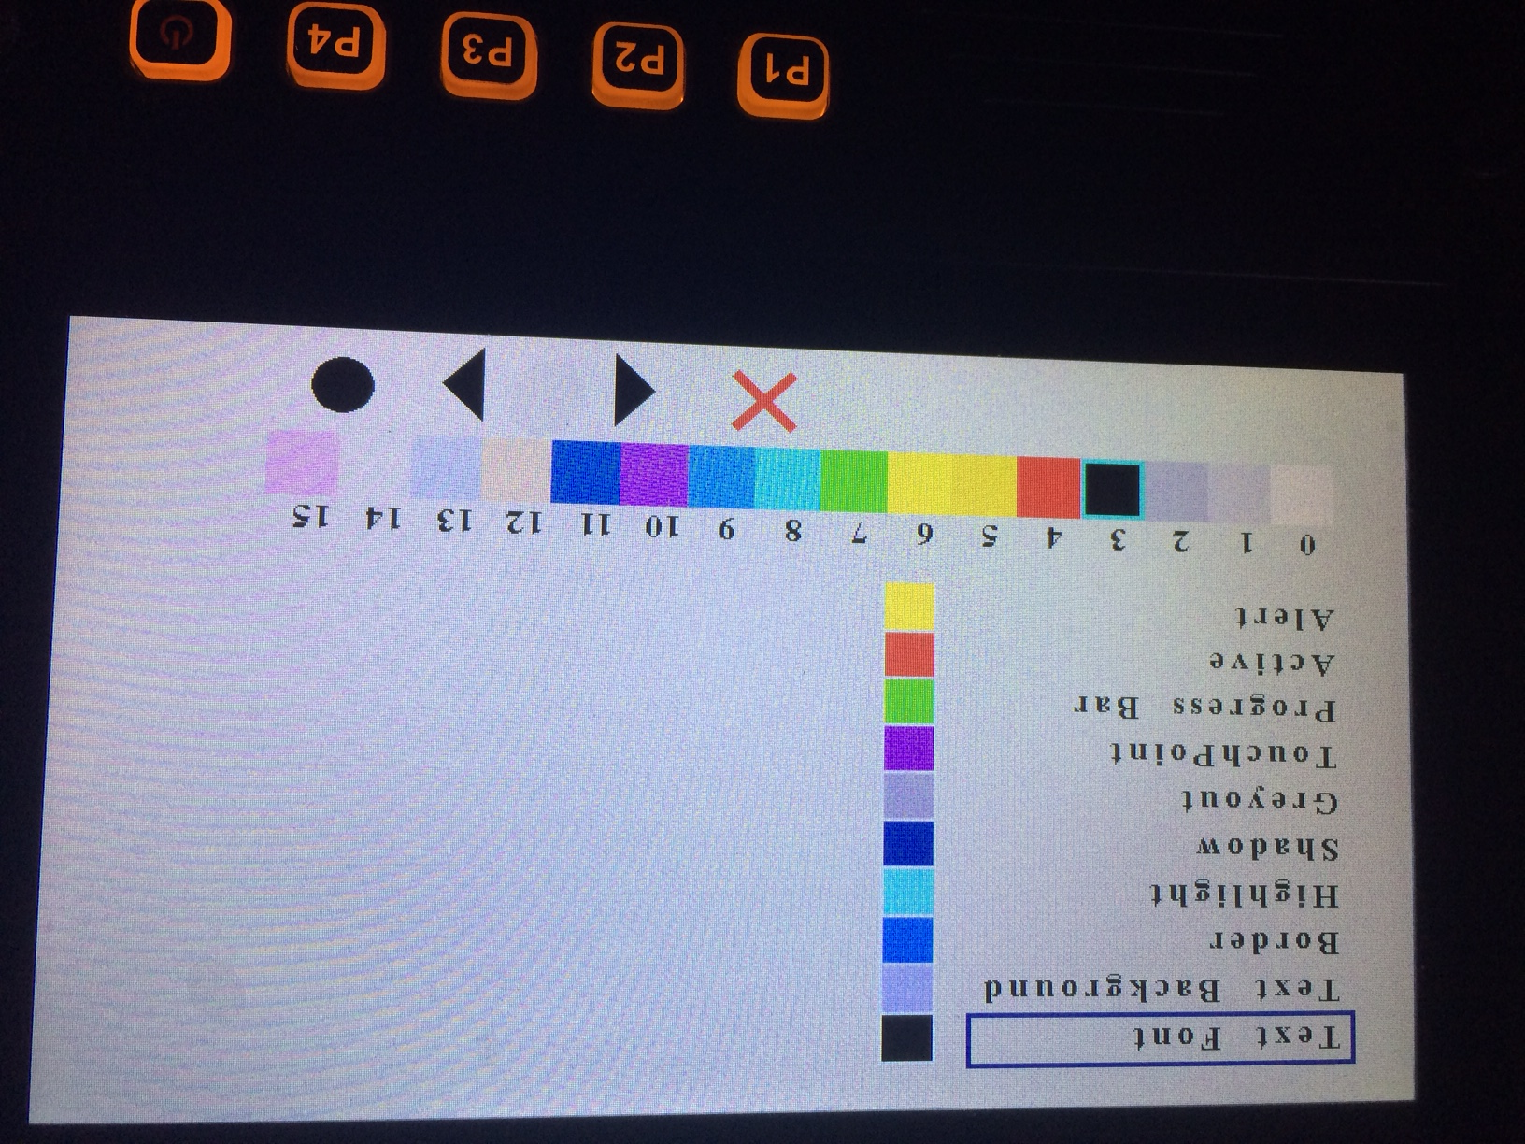

Use the left or right arrow key or P3 or P4 to select the color you want and then press the Select key or P4 to lock it in. around the key and the color of the selected item has changed to that color as shown below.

Now that white is selected, press the circle or the P4 key.

Now press the circle or the P4 key and notice that the Text Font went from black to white.

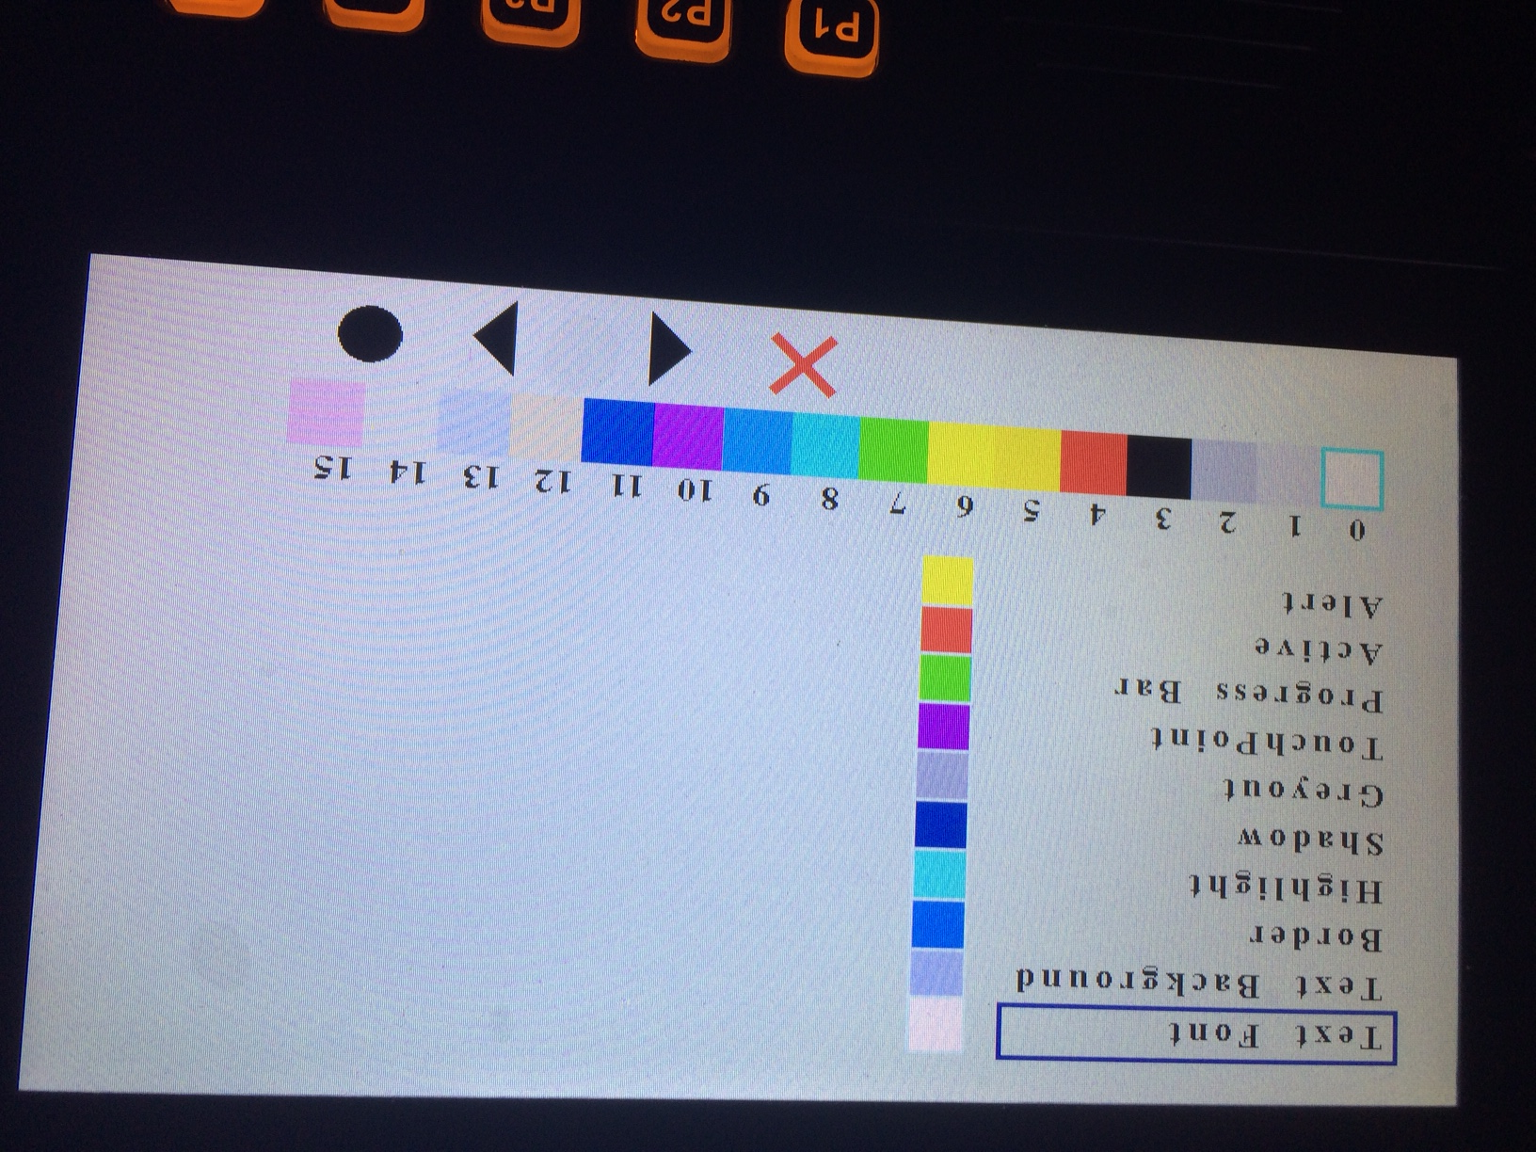

Press the red X or the P1 key and the screen will return to the previous screen as shown below.

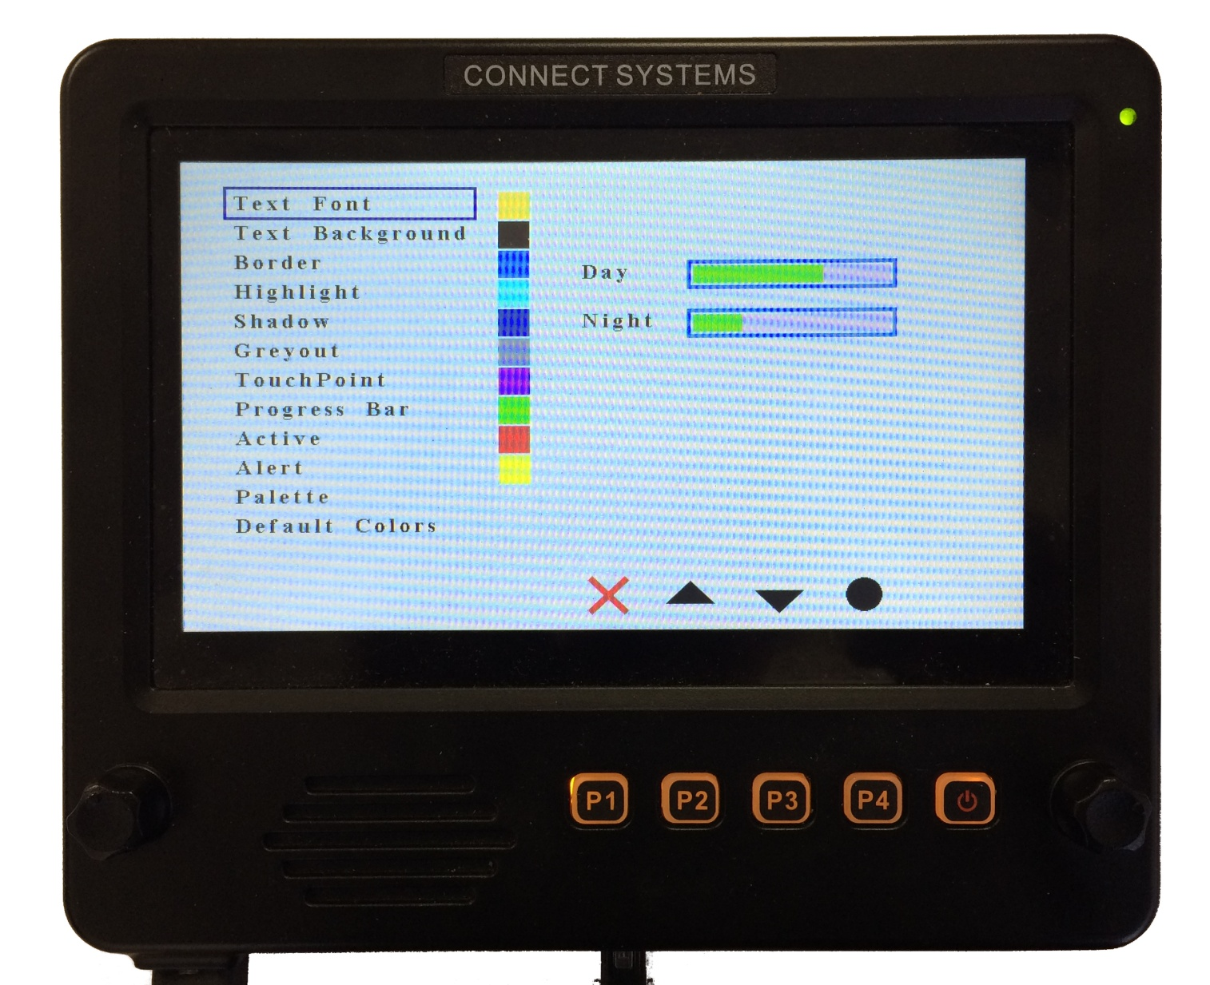

Press the red X or the P1 key one more time and you will get the following screen:
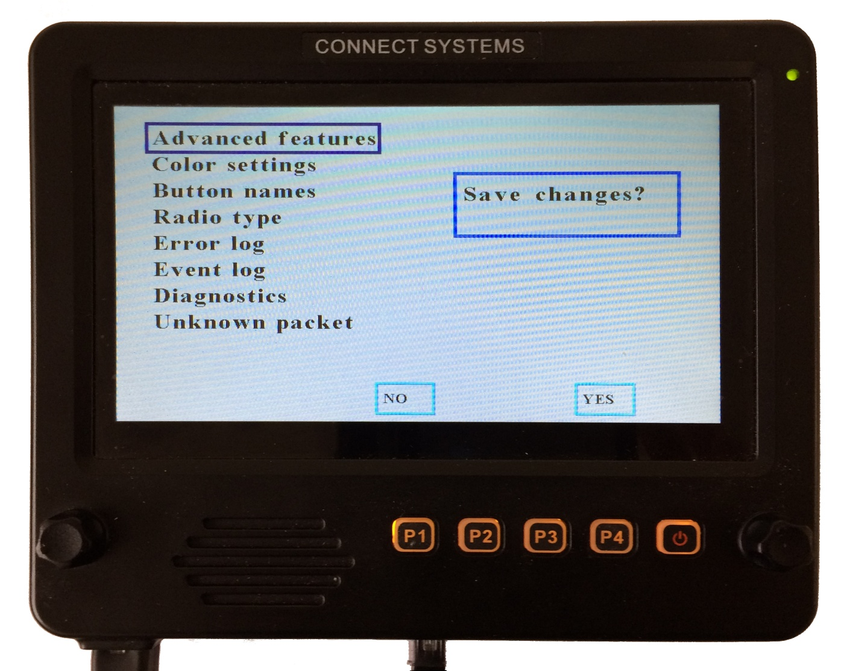

Press the Yes or P4 key and you are finished. Pressing the rotary switch on the right will return you to the main screen as shown below.

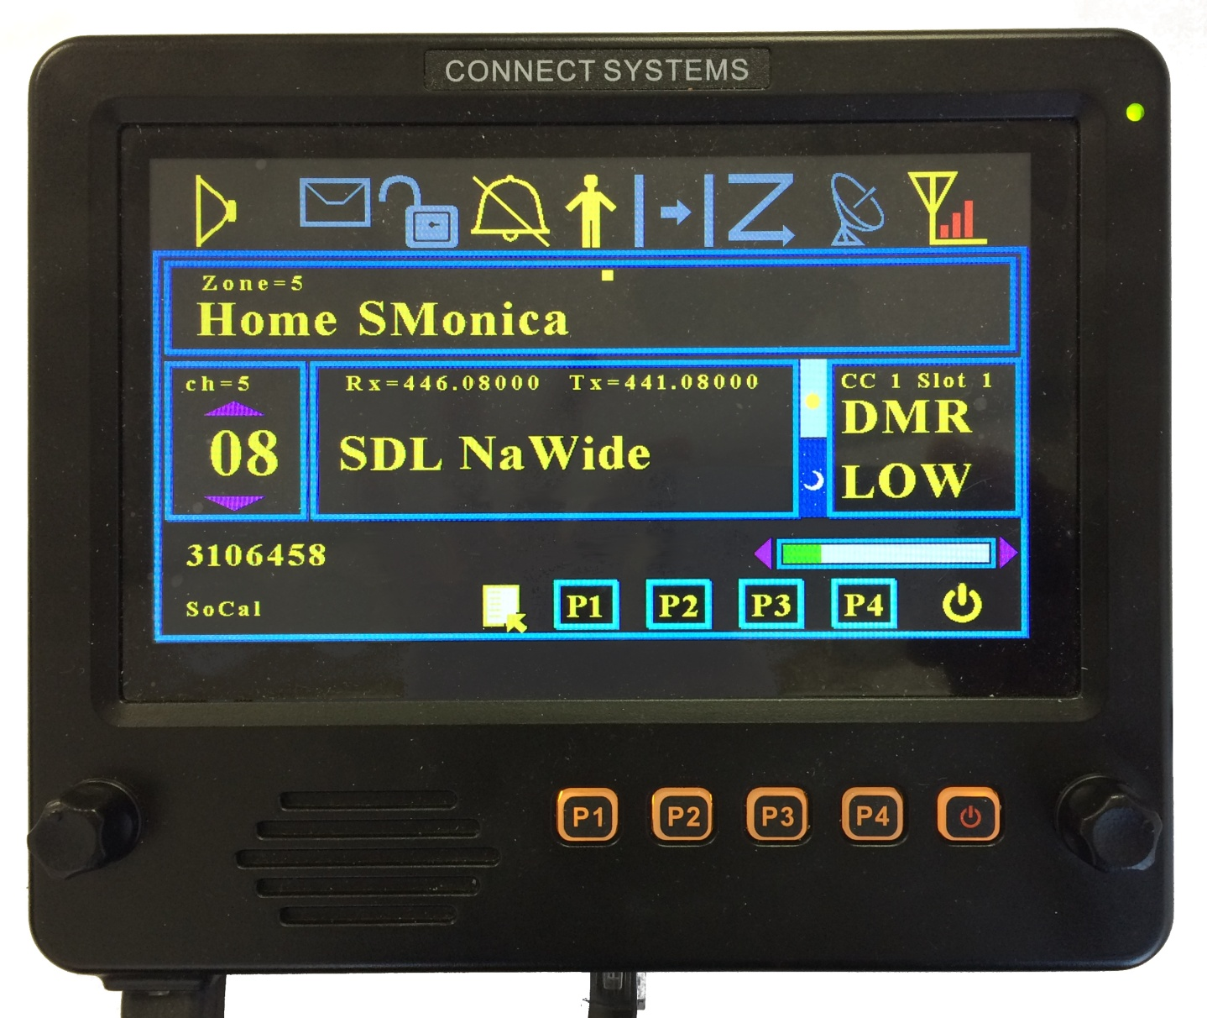

Button Names

This is a future feature where the functions of the button that you selected in the CPS when programming the radio will be displayed on the screen.

Radio Type

This feature is used to select which is the active radio. At the current time the only choices is

CS800D UART 1
FT857D UART 1

FT857D UART 2 is not currently available.

ERROR LOG

There are a significant number of traps in the firmware to look for problems that should never happen. The error log records the information and allows the user to see those. The customer should take a photo of those errors and send it to the factory to allow us to make the firmware better.

EVENT LOG

To help with diagnostics, especially when there is a problem, we provide a screen that shows the major transaction the CS-BFD processed. We might ask you to take a photo of this screen to help resolve unknown issues.

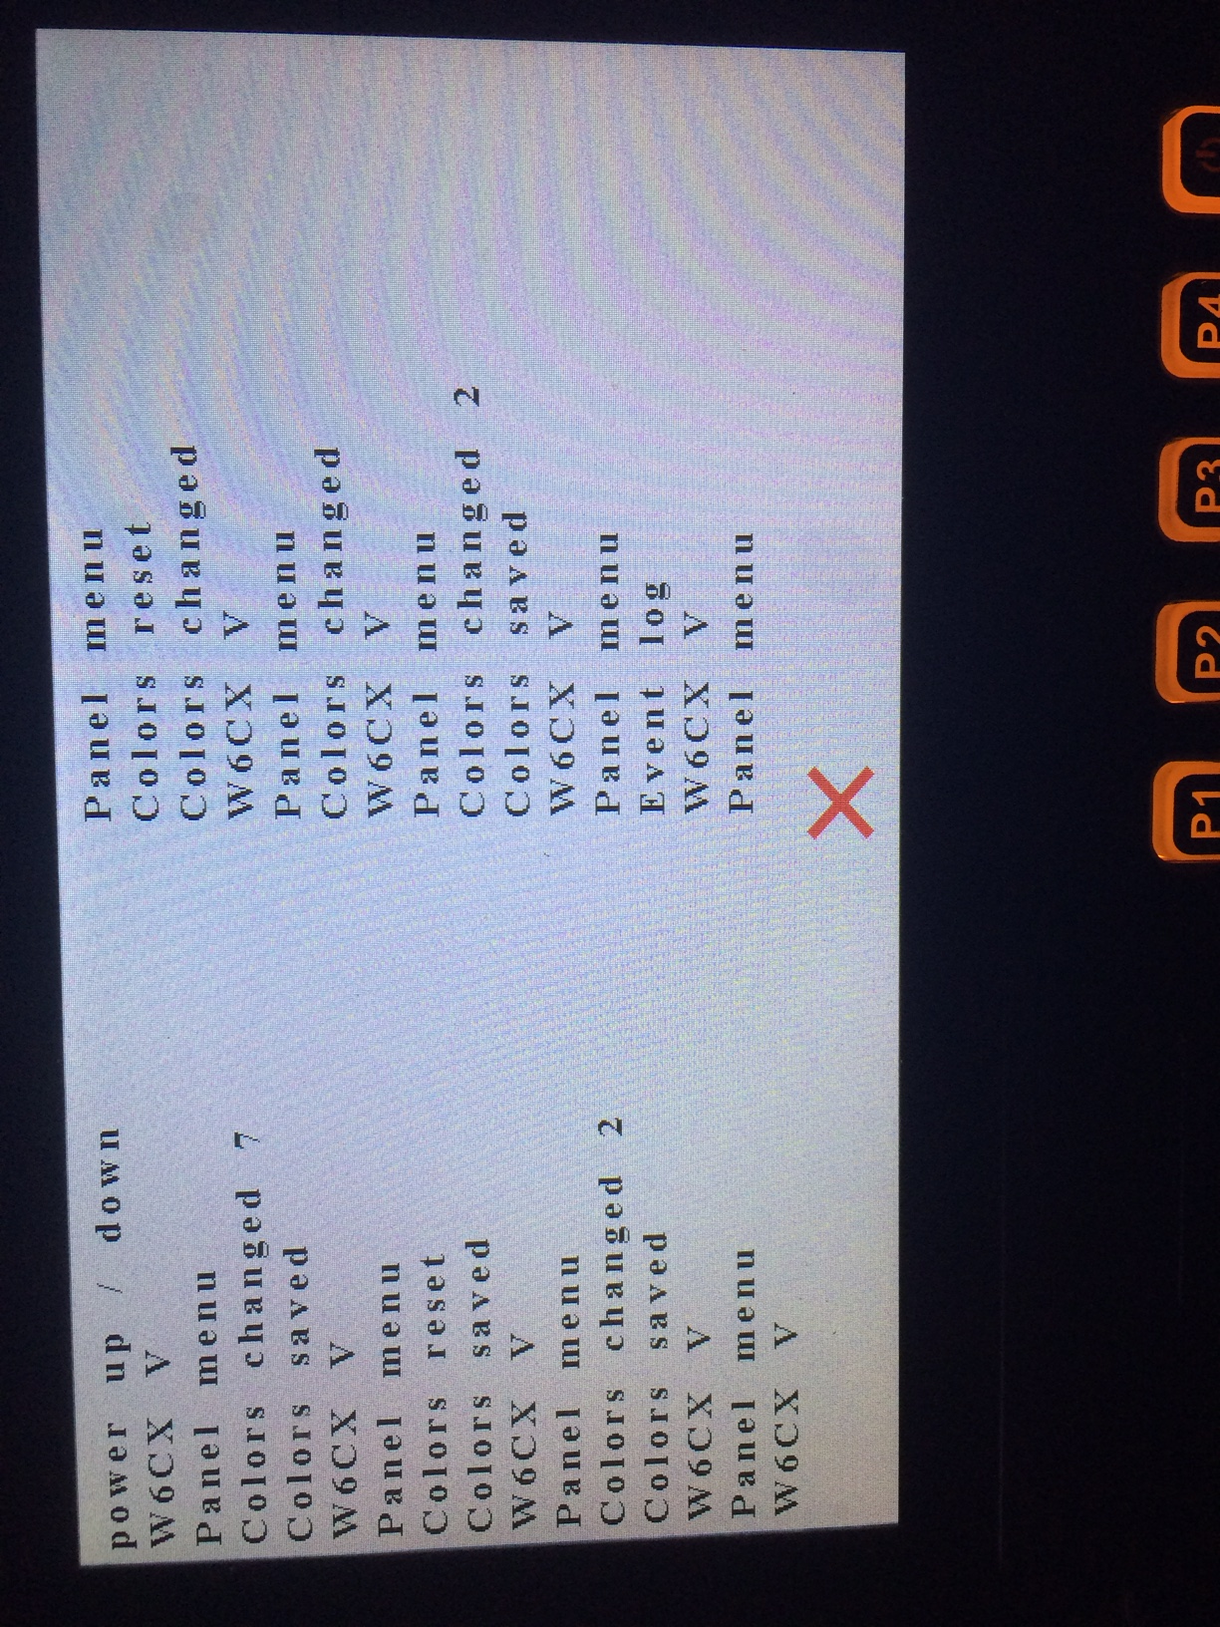

DIAGNOSTICS

To help with hardware problems, the CS-BFD has a complete set of hardware diagnostic test that should isolate any problems.

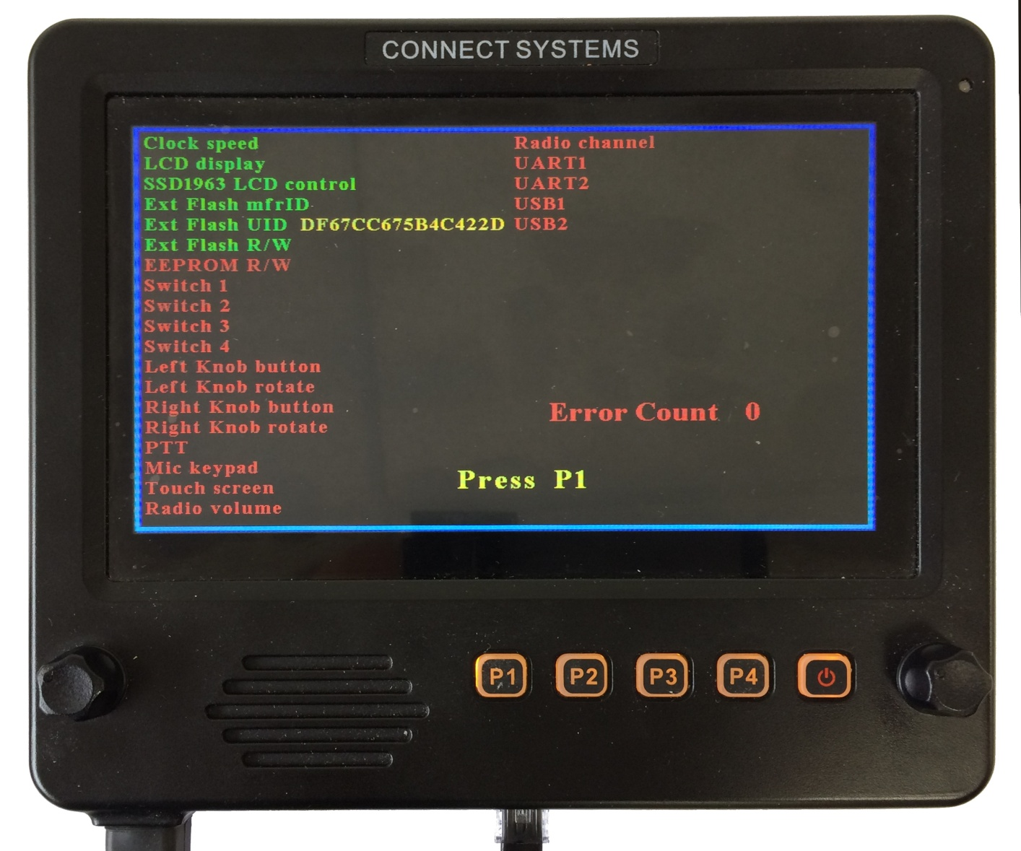

If all the hardware diagnostics test passed, you get the following screen.

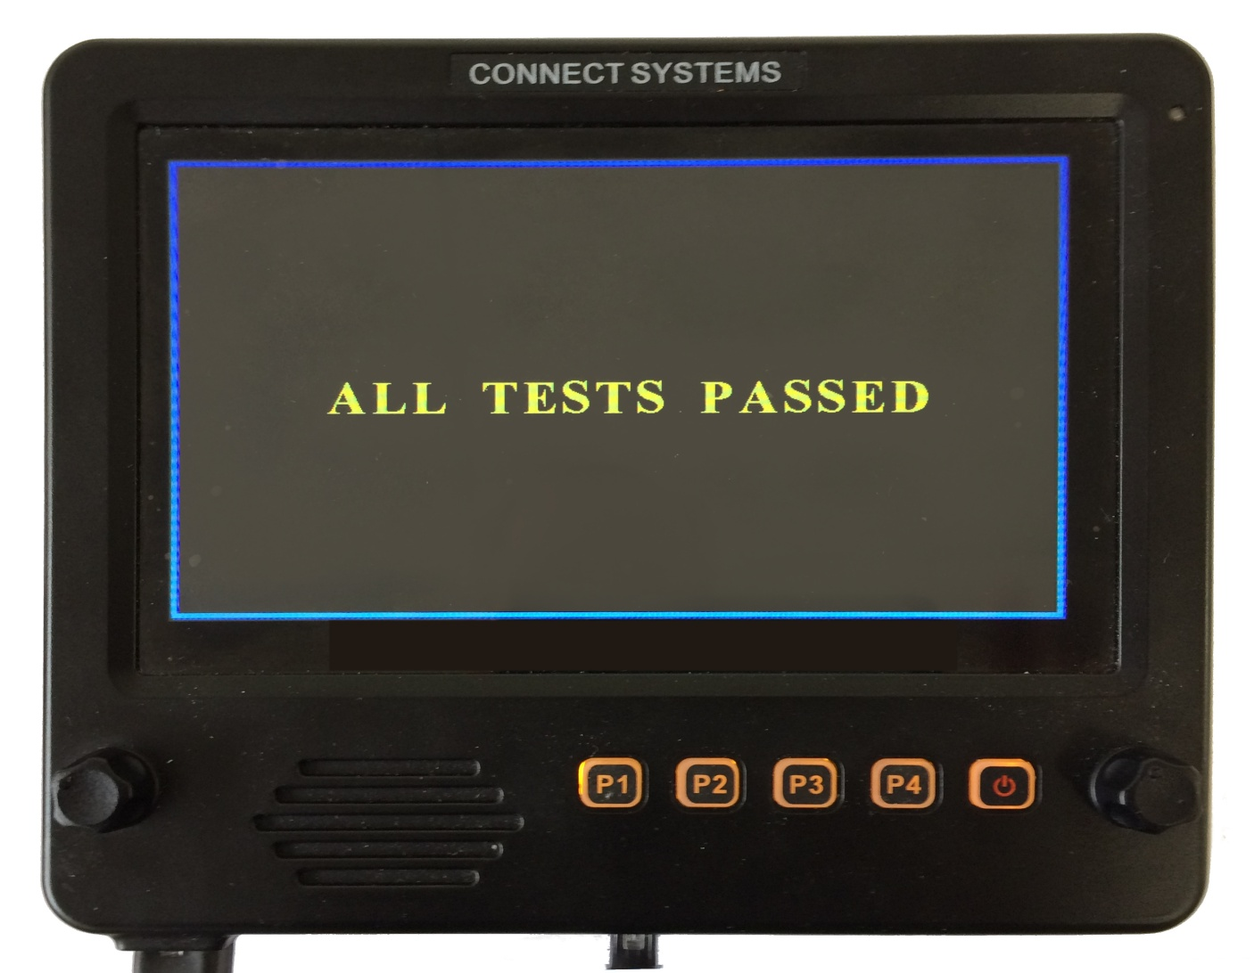

In order to have all test passed, it is necessary to make shorting plugs for USB1, USB2, and the UART port.

Unknown Packet

The design of this product is based on reverse engineering the operation of the radio attached to the CS-BFD. Different packets are sent from the radio dependent on the keys the user presses and what is happening with the radio. It is possible we never seen a particular event happen and that event gives us a packet we have never seen before. If that happens we capture and store the packet and that packet will be displayed in this screen.

This error indicates there is an unknown packet and the user should take a photo of this screen as well as the event log screen and the unknown packet screen and e-mail it to connect systems so we can fix the problem.

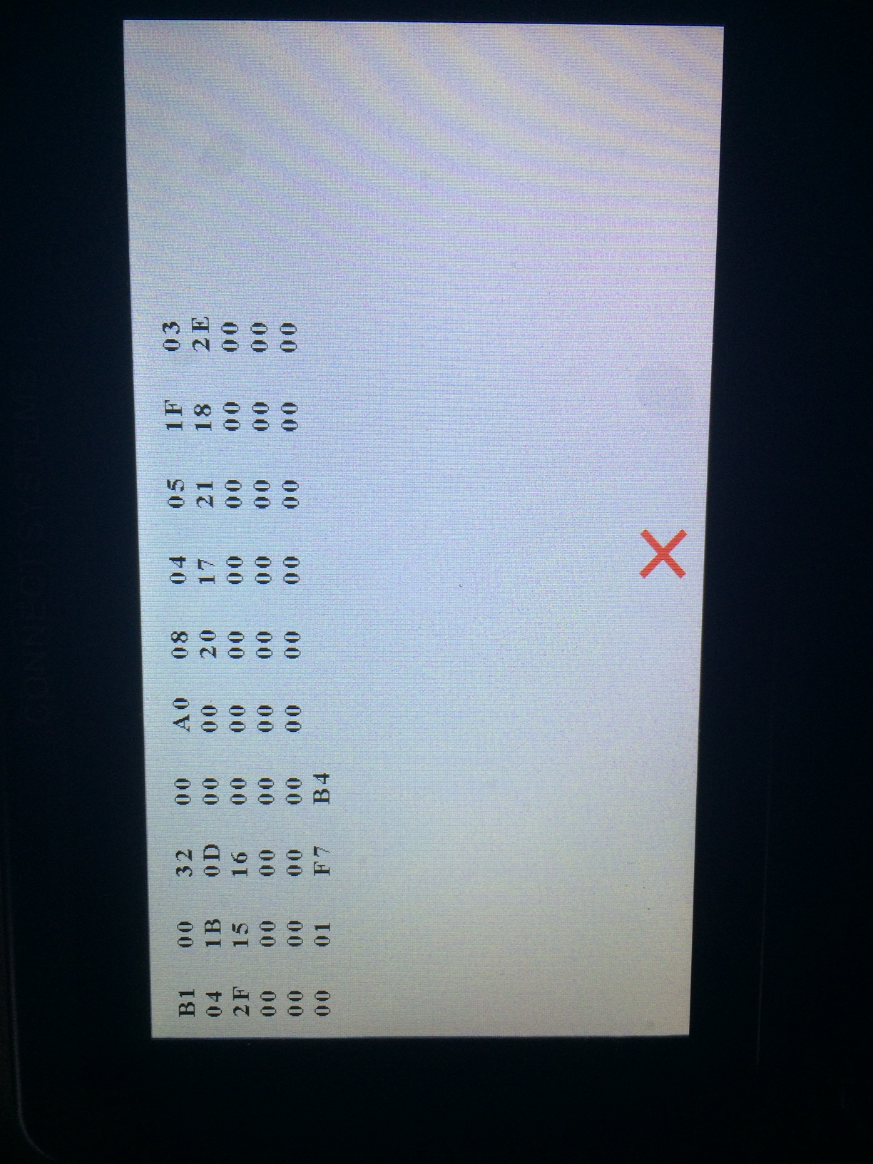

ADVANCED FEATURES

Pressing the rotary switch on the right will bring up the following screen

The up and down arrow on the touch screen or P2 or P3 or the right rotary switch will select which feature you want to select. The solid circle on the touch screen or P4 will select that feature that is highlighted. To exit from this menu select press the Red X on the touch screen or P1. The next picture will show the results of selecting the Advanced features.

The up and down arrow on the touch screen or P2 or P3 or the right rotary switch will select which feature you want to select. The solid circle on the touch screen or P4 will select that feature that is highlighted.

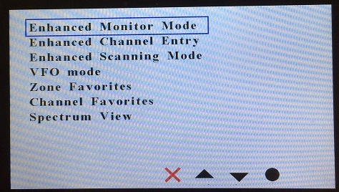

Summary of the Advanced Features

Enhanced Monitor Mode
With this feature, your display will show graphically the different groups being received and the relative length of time that group has been active. The next display will be a table that will give the group verses its active time

Enhanced Channel Entry
From a single screen, you will be able to enter all the parameters necessary for creating a channel. You will then be able to lock it in and start communicating with the channel you just set up.

Enhanced Scanning Mode
This feature will allow you to scan between two frequencies and then temporarily lock it in and use it for communication with the conversation in progress. A future version of this feature will allow you to permanently save it.

VFO Mode
You will be able to change frequencies by turning one of the rotary encoders. Various parameters associated with this feature will be able to be set from the screen instead of having to use the CPS and make a new code plug.

Zone Favorites
This feature will allow you to quickly select up to 1 of 16 preprogrammed zones. The setup of this feature is done entirely through the CS-BFD without the need for the CPS and loading a code plug. When selecting the zone, you are always starting with channel 1 of that zone.

Channel Favorites
This feature will allow you to quickly select up to 1 of 16 preprogrammed channels. The setup of this feature is done entirely through the CS-BFD without the need for the CPS and loading a code plug.

Spectrum View

This feature will allow you to see the amplitude of the signal over a frequency range. This is what is known as a spectrum Analyzer.

Enhanced Monitor Mode

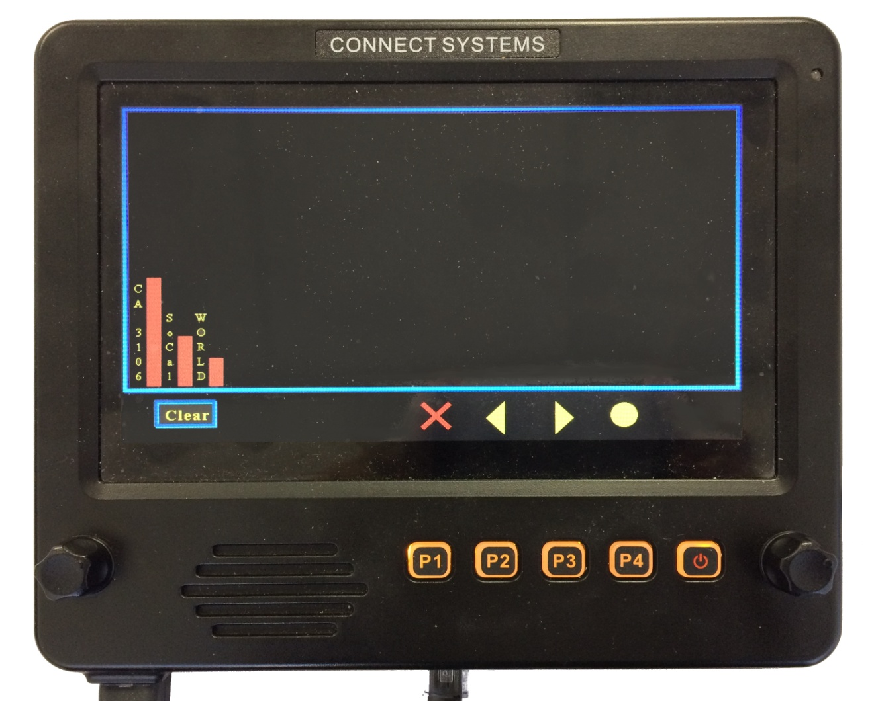

If you let the CS-BFD monitor a repeater for a length of time, the CS-BFD will gather the activity on the channel and display it in graphical form as shown in the above screen. If you want to see the details of the various groups, press the right arrow key or P3 and you will get the display shown on the next page.

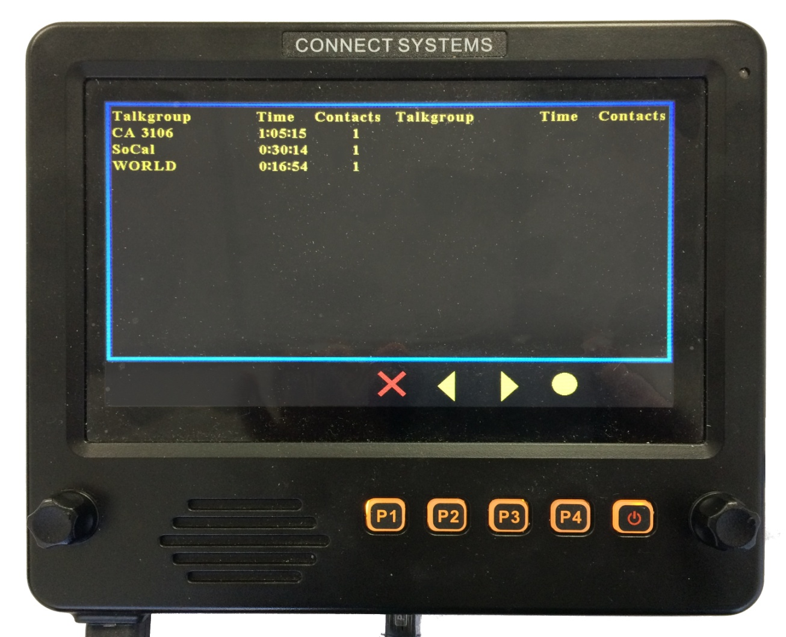

Notice the display shows the name of the talk group, how long the channel was occupied, and the number of times someone tried to use that talk group.

Enhanced Channel Entry

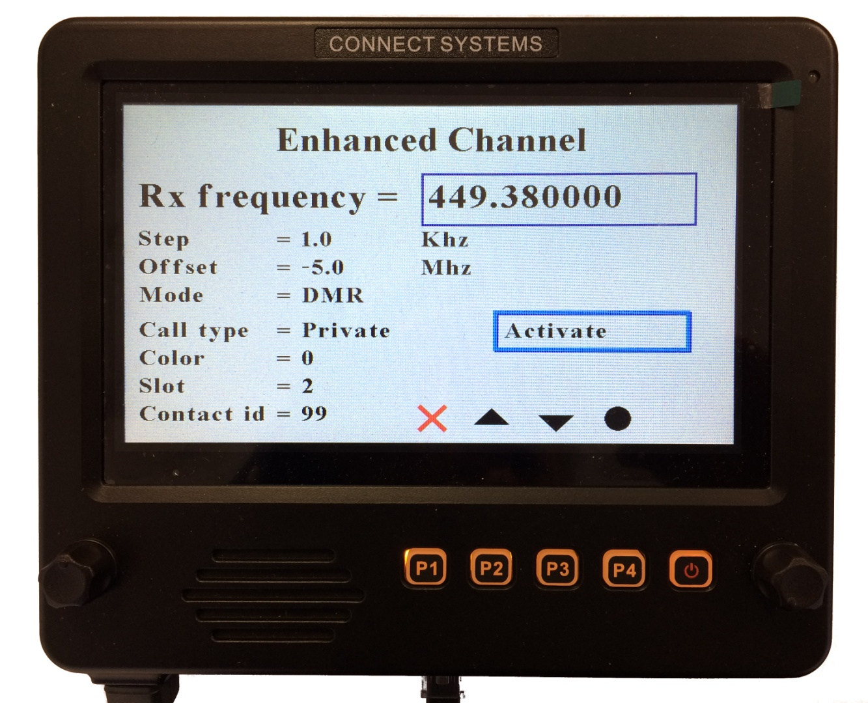

To move between parameters in this and other menus, the box around the parameter must be blue. When it is red it means you can change the value of the parameter. The change the active parameter position, use the right encoder, the up and down arrow keys, or P2 and P3.

To enter a parameter, use P4 or the enter position on the touch screen. To exit from a parameter, use P1 or the red X position on the touch screen. In some parameters but not all, pressing P4 or the enter position on the touch screen will get you both in and out of that parameter.

Rx frequency
This selects the Rx frequency either by turning the right encoder switch or a direct entry by using the DTMF keypad on the microphone. Pressing the enter key twice exits from this menu.

Step
This is the step size when adjusting the Rx frequency. The possible entries are:
10 Hz
20 Hz
50 Hz
100 Hz
250 Hz
500 Hz
1,000 Hz
5,000 Hz
10,000 Hz
25,000 Hz
50,000 Hz
100,000 Hz
250,000 Hz
500,000 Hz
1,000,000 Hz
5,000,000 Hz

Offset
This is transmitter offset frequency from the Rx frequency. The possible entries are:
0 Hz
600,000 Hz
5,000,000 Hz
-5,000,000 Hz
-600,000 Hz

Mode
This selects between Analog and Digital Mode

Call Type
This is a DMR only parameter and gives you a choice of Private, Group, or All.

Color
This is a DMR only parameter and allows you to select the color code from 0 through 15.

Slot
This is a DMR only parameter and allows you to select Slot 1 or Slot 2

Contact id
This is a DMR only parameter and allows you to enter the ID through the DTMF microphone keypad.

Squelch type
This is an Analog only parameter and allows you to select between the following:
1. None
2. CTCSS
3. DCS
4. -DCS (sometimes known as inverted DCS)

CTCSS encode
This is an Analog only parameter and allows all standard values between 67 Hz to 254.2 Hz.

CTCSS decode
This is an Analog only parameter and allows all standard values between 67 Hz to 254.2 Hz.

DCS encode
This is an Analog only parameter and allows all standard values between 023 and 754.

DCS decode
This is an Analog only parameter and allows all standard values between 023 and 754.

Once you finish changing the parameters as necessary, press the Activate button twice and you will get the following screen:

THIS SHOULD BE THE TEMP DCH CHANNEL SCREEN
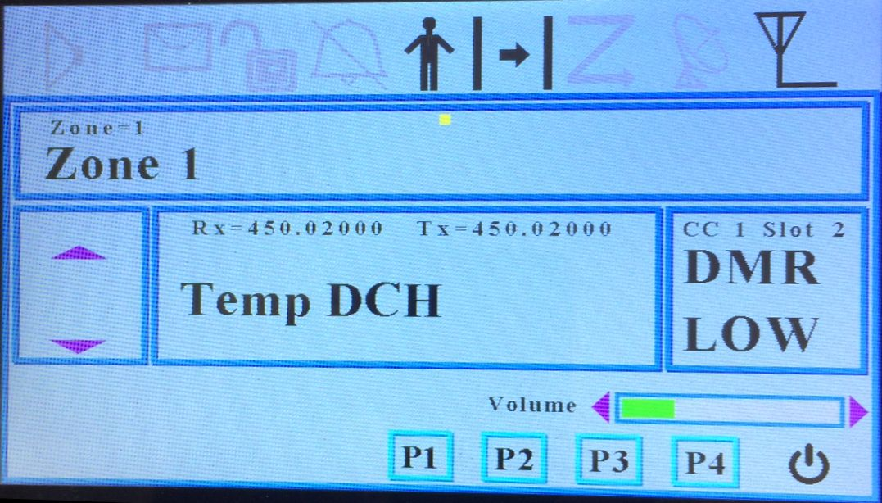

Notice the screen name is “Temp” and the other parameters is what was programmed in the previous screen. You are ready to press the PTT button on the microphone and start talking to someone.

Enhanced Scanning Mode

The purpose of the enhanced scanning mode is to look for activity between two frequencies. When you get into the Enhanced Scan mode you get the following screen:

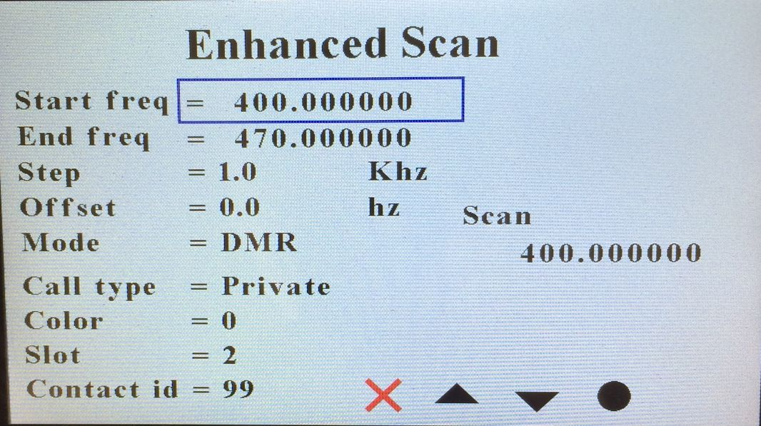

To change the parameters associated with this function, scroll to the appropriate parameter you want to change and then press the P4 key. This will change the rectangle around the parameter from a Blue to a red as shown below:

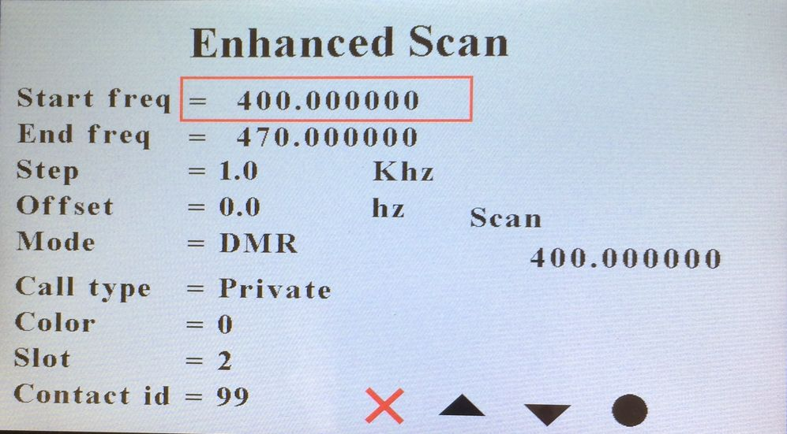

Now change the parameter by entering it from the microphone followed by a P4 or you can sometimes using the encoder on the right side to increment or decrement the value. Once you change the value as shown below, just use the up and down arrows to move to the next parameter.

Once you changed all the parameters you though were relevant, move the cursor as shown below

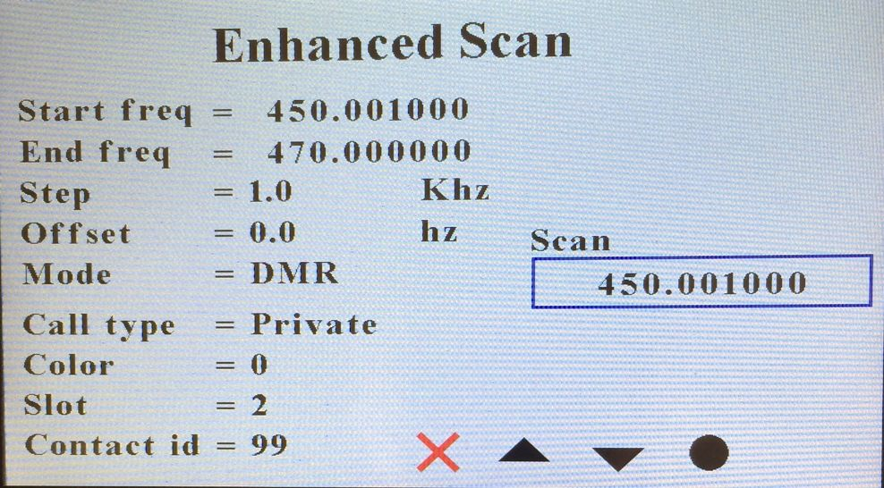

Then press the P4 key to turn the box to red and it is now scanning.

The call type, color, slot, and contact id does not have to be entered because the radio will be scanning in promiscuous mode and will stop at any digital channel that has activity. Pressing the P1 key at any time will abort from the scanning mode.

If it picks up a signal, this screen will change as follows:

VFO Mode

The purpose of the VFO mode is to allow the user to manually scan the different frequencies to find an active channel. This feature makes more sense in Analog because in digital the channels are usually predetermined in advance and you should only look for specific channels. When you press the VFO Mode from the menu, you get the following screen

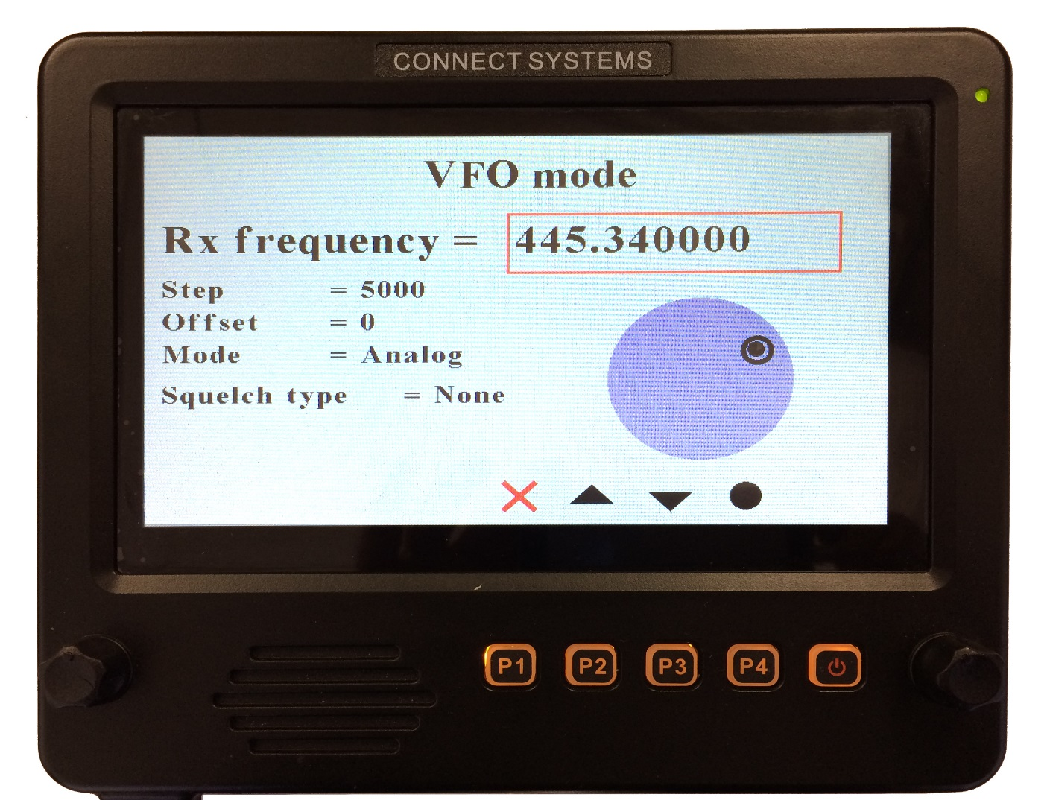

If you were going to get a digital VFO channel you will get the following:

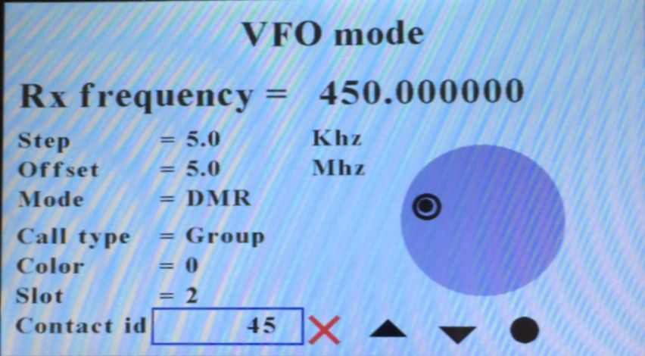

To change the parameters, use the up and down arrow to select the parameter as shown above.

Then press the P4 key and you will get the following:

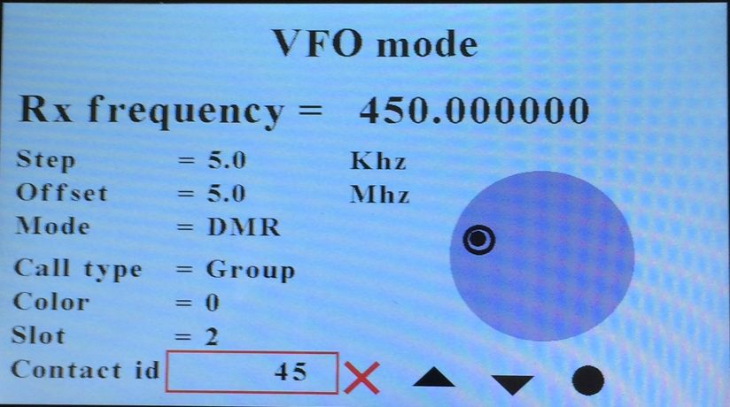

Notice the red box around the parameter you want to change.

And press the P4 key and you should see the following:

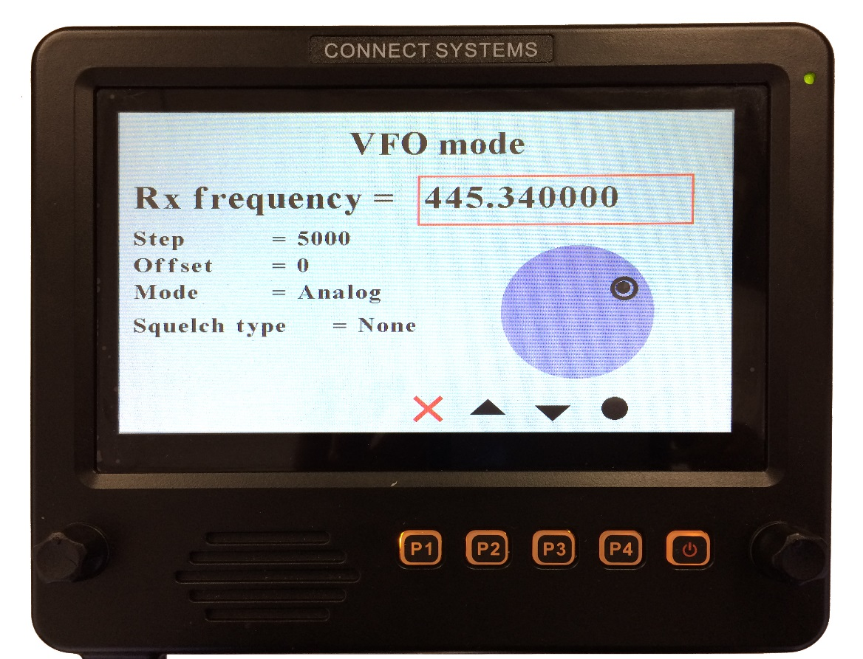

Now you can use the right rotary knob to increment of decrement the frequency.

There is an idiosyncrasy to this function now, that will be fixed in the future. If you wanted to change the Rx Frequency, you would use the keypad on the mike and then press the P4 key to enter it. At this point the feature is locked. Use the P1 key to go down one level and then go back in the VFO mode and everything is good.

Zone Favorites

When you select Zone Favorites, you get the following screen. You can get here directly by pressing the name of the zone on the touch screen from the home page.

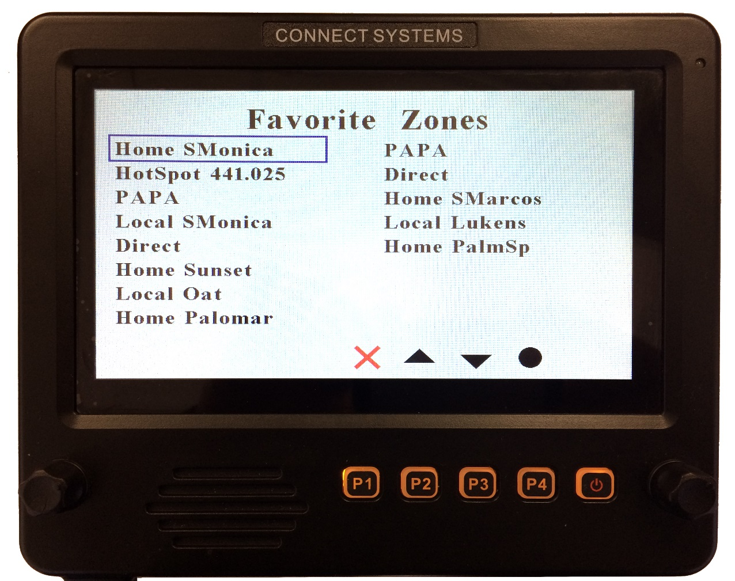

To select a favorite zone, use the right rotary knob or the up and down keys to select the zone you want to jump to and then press the solid circle or the P4 key. Alternatively, press the favorite zone on the screen.

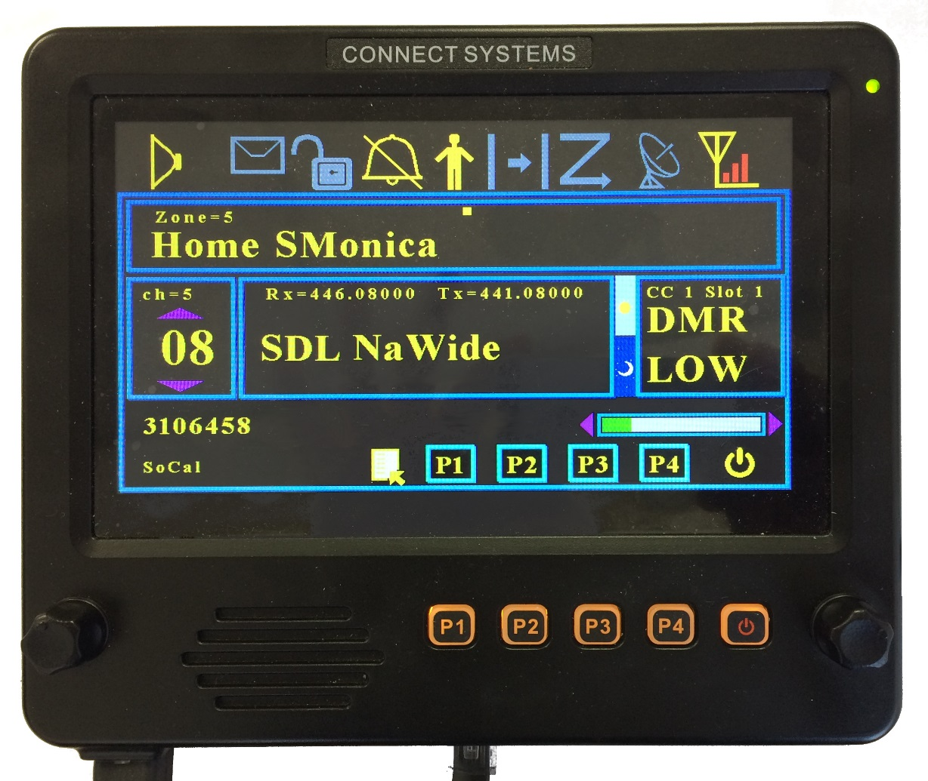

Note that just above the caption "Home SMonica" it says Zone = 5. That tells you the zone number that channel is on. Below that caption, you will see ch = 5. That is the channel number. The 05 refers to the channel number within the zone.

If you want to add a new favorite zone, first move the box to a free zone or to an existing zone.

Then press the “1” key on the keypad of the DTMF microphone. The box will then be erased and the box will show “zone = “ with a blinking cursor for you to enter the zone number as shown below.

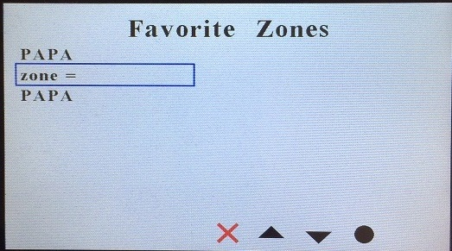
After you finished entering the zone number, press the “O” key from the keypad of the DTMF microphone, the P4 key, or the black circle on the display above the P4 key.

The new favorite zone will be stored, and the display will jump to the home screen with the zone you just picked.

Channel Favorites

When you select Channel Favorites, you get the following screen. You can get here directly by pressing the name of the channel on the touch screen from the home page.

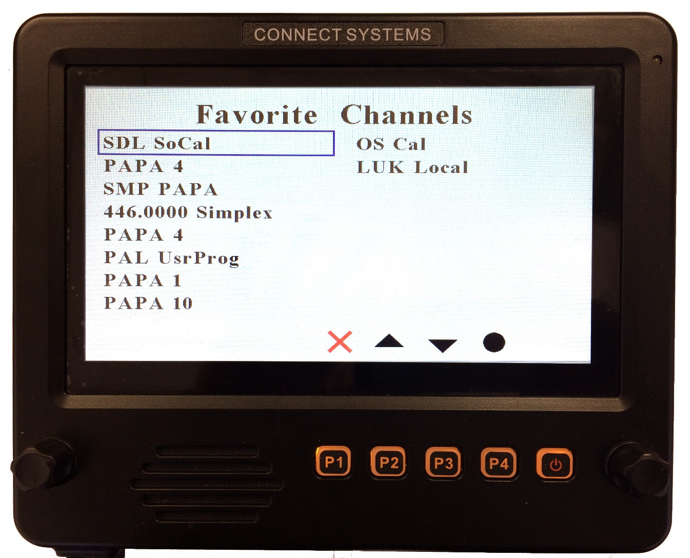

To select a favorite channel, use the right rotary knob or the up and down keys to select the zone you want to jump to and then press the solid circle or the P4 key. Alternatively, press the favorite channel on the screen.

If you want to add a new favorite channel, first move the box to a free channel or to an existing channel.

Then press the “1” key on the keypad of the DTMF microphone. The box will then be erased and the box will show “zone = chan =“ with a blinking cursor for you to enter the zone number as shown below.

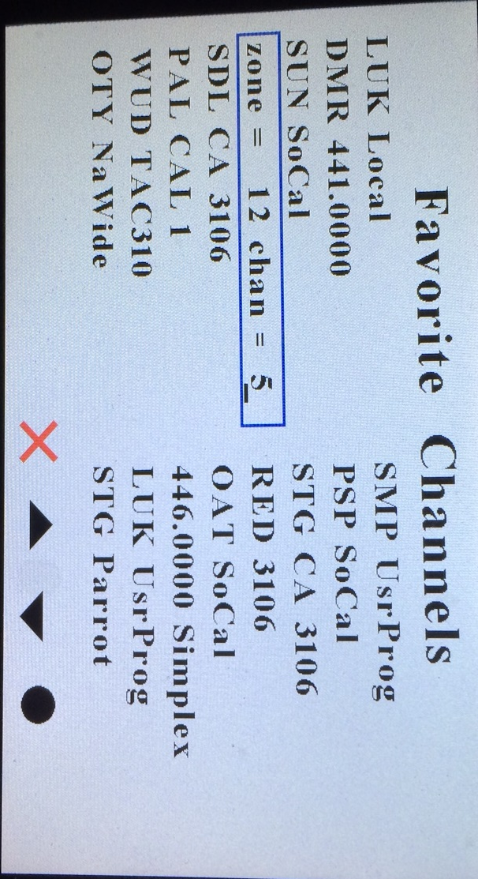

The zone number can be between 1 and 250. After you finished entering the zone number, press the “O” key from the keypad of the DTMF microphone, the P4 key, or the black circle on the display above the P4 key. The blinking cursor will then move to allow you to enter the channel number. The channel number is the number within the zone and is between 1 and 16. Enter the appropriate channel number and then press the “O” key from the keypad of the DTMF microphone, the P4 key, or the black circle on the display above the P4 key.

The new favorite zone will be stored, and the display will jump to the screen with the zone and channel you just picked.

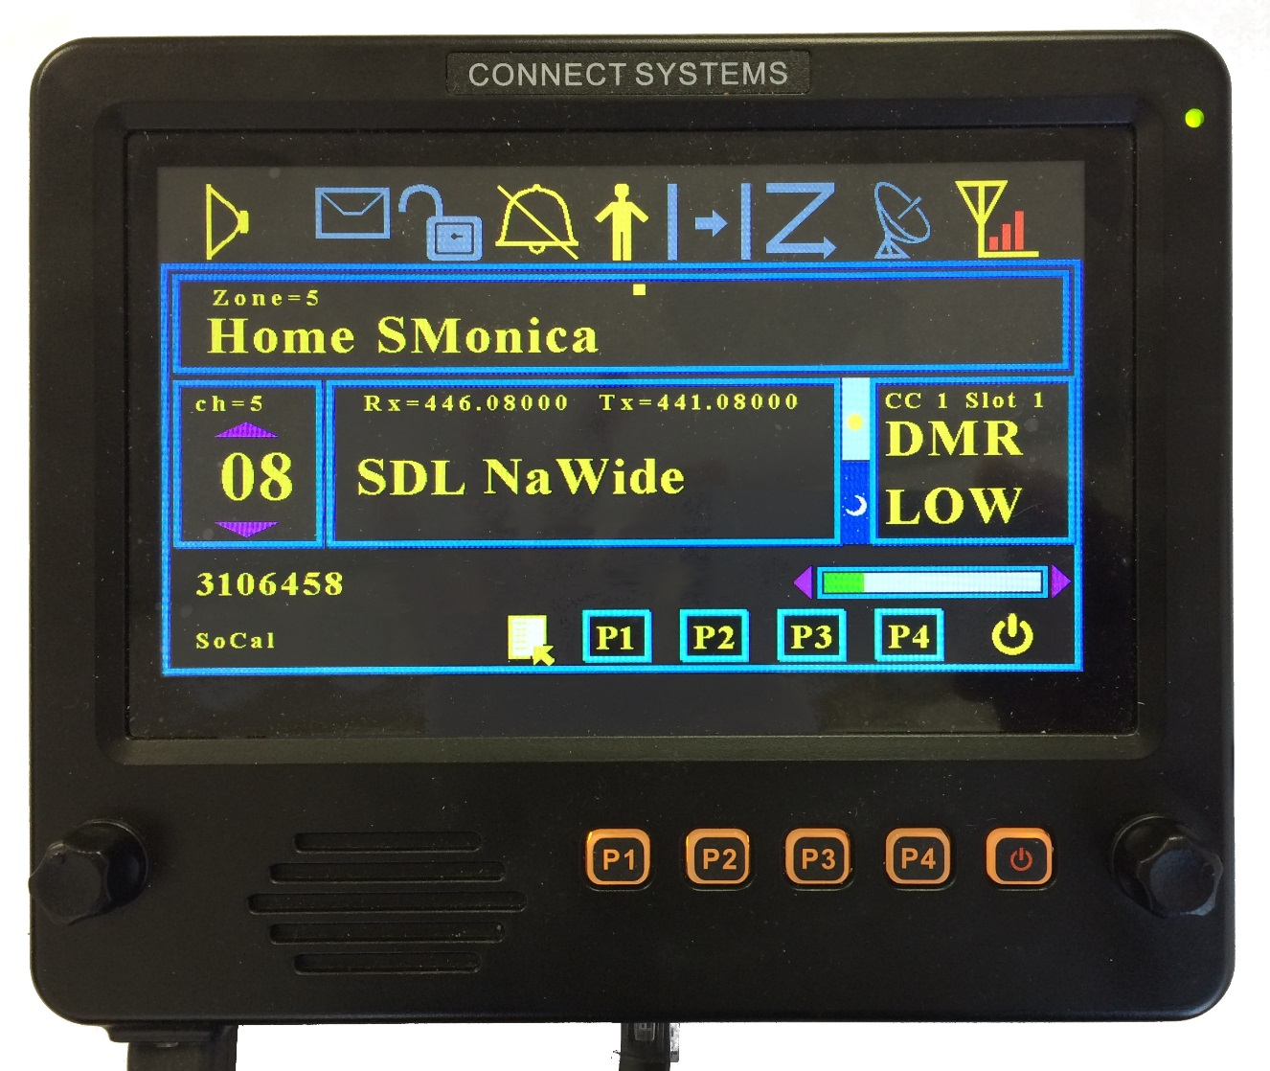

Note that just below the caption "Home SMonica" it says ch = 5. That tells you the channel number that channel is on. The 08 refers to the channel number within the zone. The Zone number is above the caption " Home SMonica ".

Spectrum View

The spectrum view is a built in spectrum analyzer. It shows frequency verses amplitude. There are two parameters than can be adjusted in this screen…. Step size and center frequency. To access these parameters, press the select key.

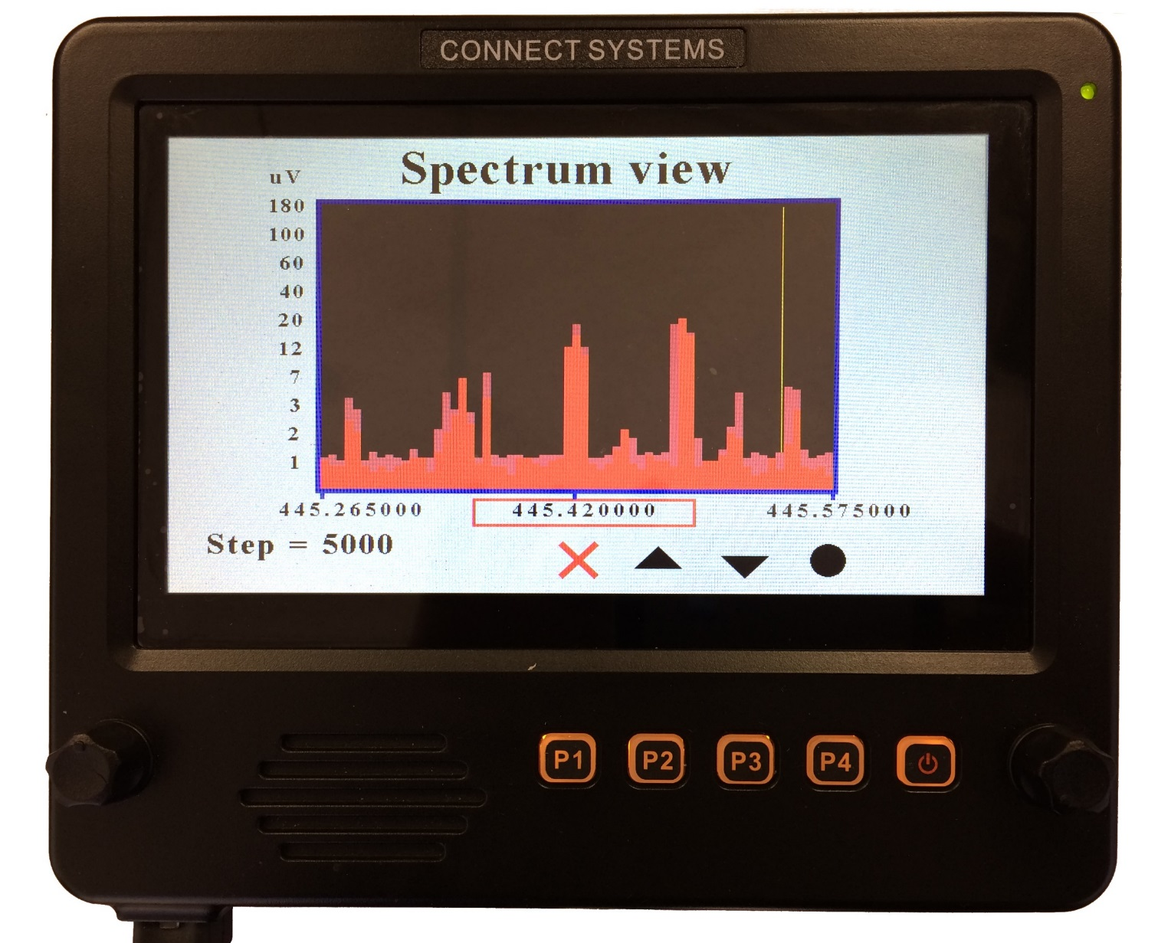

You can select between the step sizes by the right encoder or the up and down keys on the display, P2 and P3, and the keypad on the DTMF microphone. Once you select the size press the select key.

Center Frequency
Once you select the center frequency, you can change it by the right encoder or the up and down keys on the display, P2 and P3, and the keypad on the DTMF microphone. The step size determines how much the center frequency is going to change every time you press a key.

Step size
This is the step size when adjusting the Rx frequency. The possible entries are:

10 Hz
20 Hz
50 Hz
100 Hz
250 Hz
500 Hz
1,000 Hz
5,000 Hz
10,000 Hz
25,000 Hz
50,000 Hz
100,000 Hz
250,000 Hz
500,000 Hz
1,000,000 Hz

FRONT OF THE CS-BFD

The P1, P2, P3, and P4 corresponds to the P1, P2, P3, P4 on the CS800D. When used with other radios, they might have different meanings. The two knobs on the edges correspond to the rotary knob on the CS800D and the Up and Down button on the CS800D. Both of those rotary knobs can be pushed for additional functions like on the CS800D. Please look in the operations manual of this document on how those keys are used.

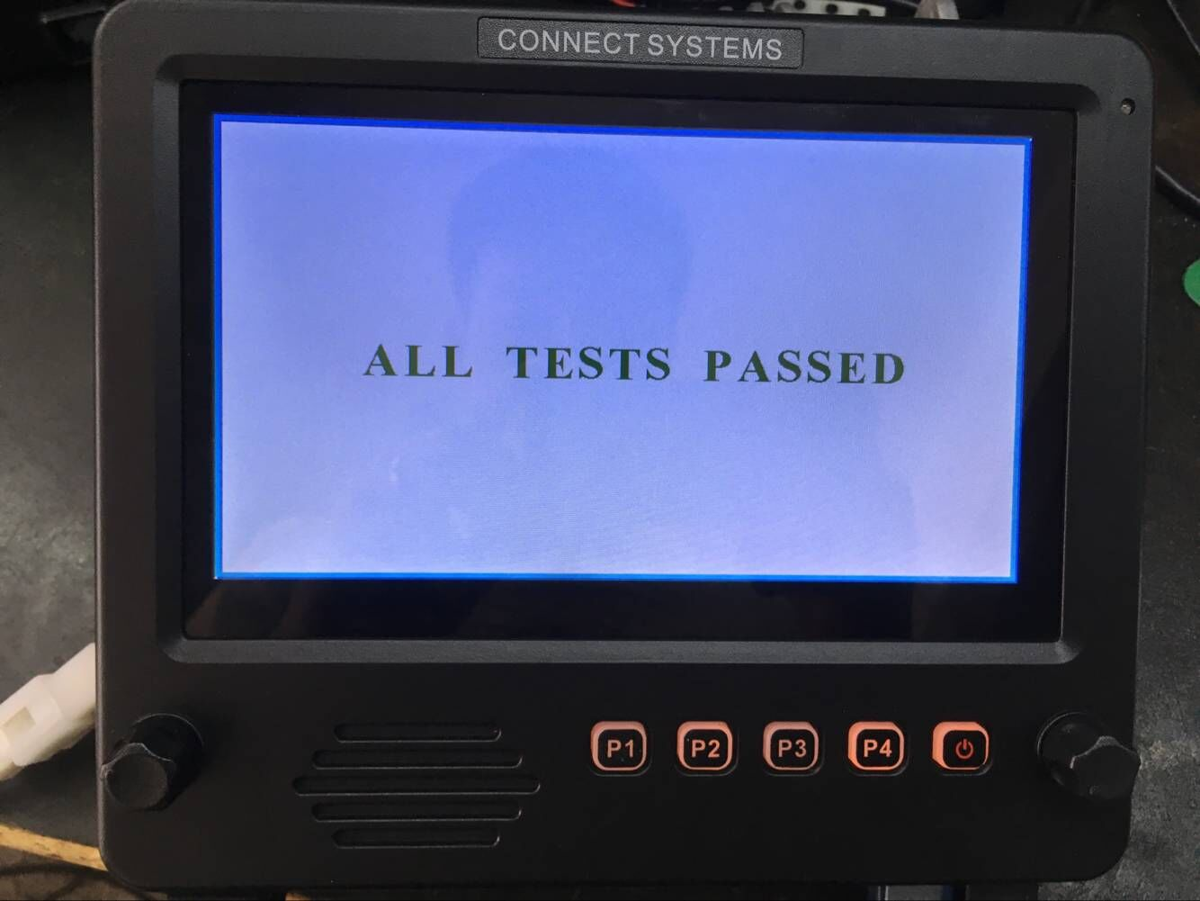

CS-BFD Operation

Board Jumpers
JP1 selects if the power to the unit is coming from an external power supply plugged into the jack or from a radio.
JP2 is the Debug Connector for those advanced users who want to modify the firmware.
JP3 is used for putting the unit in boot mode if the unit is bricked
JP4 selects if the backlit keys are on or off.

POWER
Power for the unit is supplied by the CS800D, CS800, or CS801 radio under normal conditions. Under certain conditions, the user might want to power the radio either from a power supply or directly from a car battery. This selection is done by a jumper. This power goes directly to the microphone jack as well as a switching regulator IC2 that converts the voltage to 3.3V which is used for powering the rest of the circuits.

Interface to the CS800D, CS800, or CS801
The interface to the radios have the following connections:
Pin 1 (SPGND) This is the speaker ground connection from the radio. It goes directly to the internal speaker of the CS-BFD.
Pin 2 (SPOUT) This is the speaker audio connection from the radio. It goes directly to the internal speaker of the CS-BFD.
Pin 3 (8M) This is the power from the radio and is about 8 volts.
Pin 4 (RxD) This is the connection between the UART of the CS-BFD and the UART of the radio.
Pin 5 (TxD) This is the connection between the UART of the CS-BFD and the UART of the radio.
Pin 6 (POWER) This connection when grounded, turns the radio on if it is off or turns the radio off if it is on.

Pin 7 (MIC) This is the direct audio connection from the microphone
Pin 8 (GND) This is the common ground for the power and audio

Interface to the DTMF Microphone
Pin 1 (MBL) Not used
Pin 2 (8V) Power required by the microphone.
Pin 3 (GND) Ground
Pin 4 (PTT) Push to talk from the microphone
Pin 5 (ME) Microphone Ground
Pin 6 (MIC) Microphone Audio
Pin 7 (Hook) Off Hook switch connection
Pin 8 (DM) Reads the DTMF keys

Interface to USB 1 Connector
Pin 1 (VCC) 3.3 Volts
Pin 2 (D-) TxD from the UART
Pin 3 (D+) RxD From the UART
Pin 4 (GND) Ground

Interface to USB 2 Connector
Pin 1 (VCC) 3.3V
Pin 2 (D-) USB DM Connection
Pin 3 (D+) USB DP Connection
Pin 4 (GND) Ground

Interface to USB 3 Connector
Pin 1 (VCC) 3.3V
Pin 2 (D-) USB DM Connection
Pin 3 (D+) USB DP Connection
Pin 4 (GND) Ground

