**CHANGING ZONES WITH THE CS-BFD**

With most radios, there are about 250 zones available to select. With the other radios, if you are on zone 1 and you want to go to zone 250, you have to press the zone up button 250 times. With the CS-BFD, we make it easy to select your 16 favorite zones.

**STEP 1**Touch the screen where the zone name appears. That will get you to the next picture.

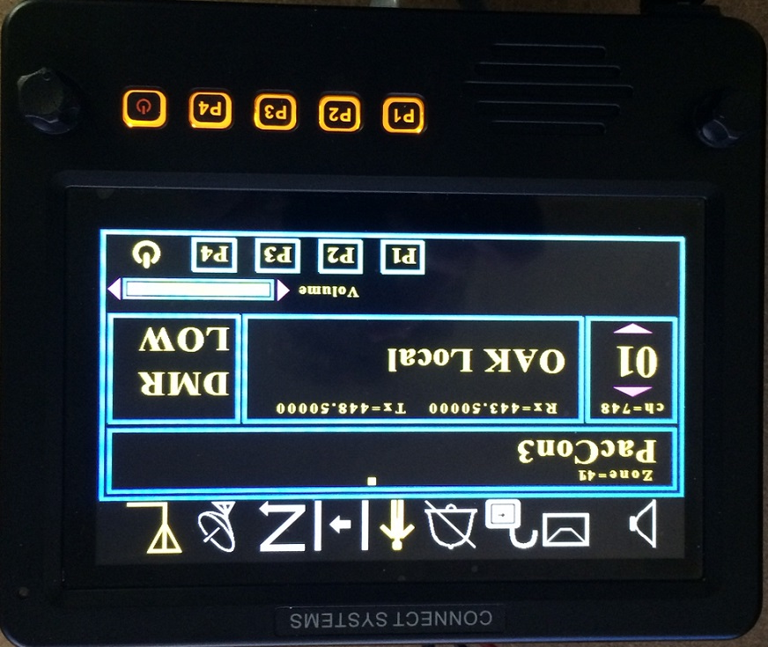

**STEP 2**  
Touch the zone you want to go to.

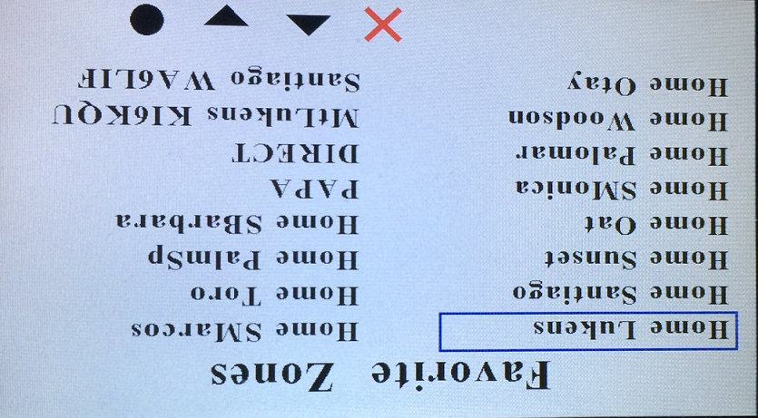

**STEP 3**There is no step 3. Soon as you touch the desired zone you get to the next picture and now you can select any channel within that zone by the channel up and channel down button.

