USING THE NEW CPS FOR BOTH THE CS800D AND CS800D PLUS
The current version of the CPS Is compatible with both the old version of the CS800D and the new version of the CS800D PLUS.
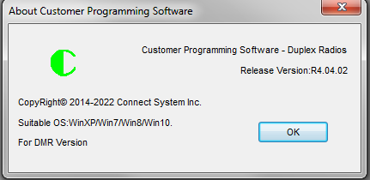
To switch between the CS800D and CS800D PLUS, turn on the radio and then select the “New” command in the file pull down menu.
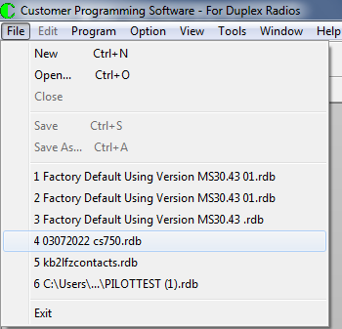
Pick the appropriate radio from the list as shown below.
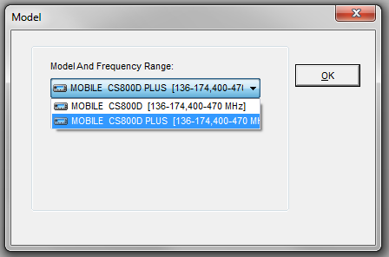
And press the OK key.
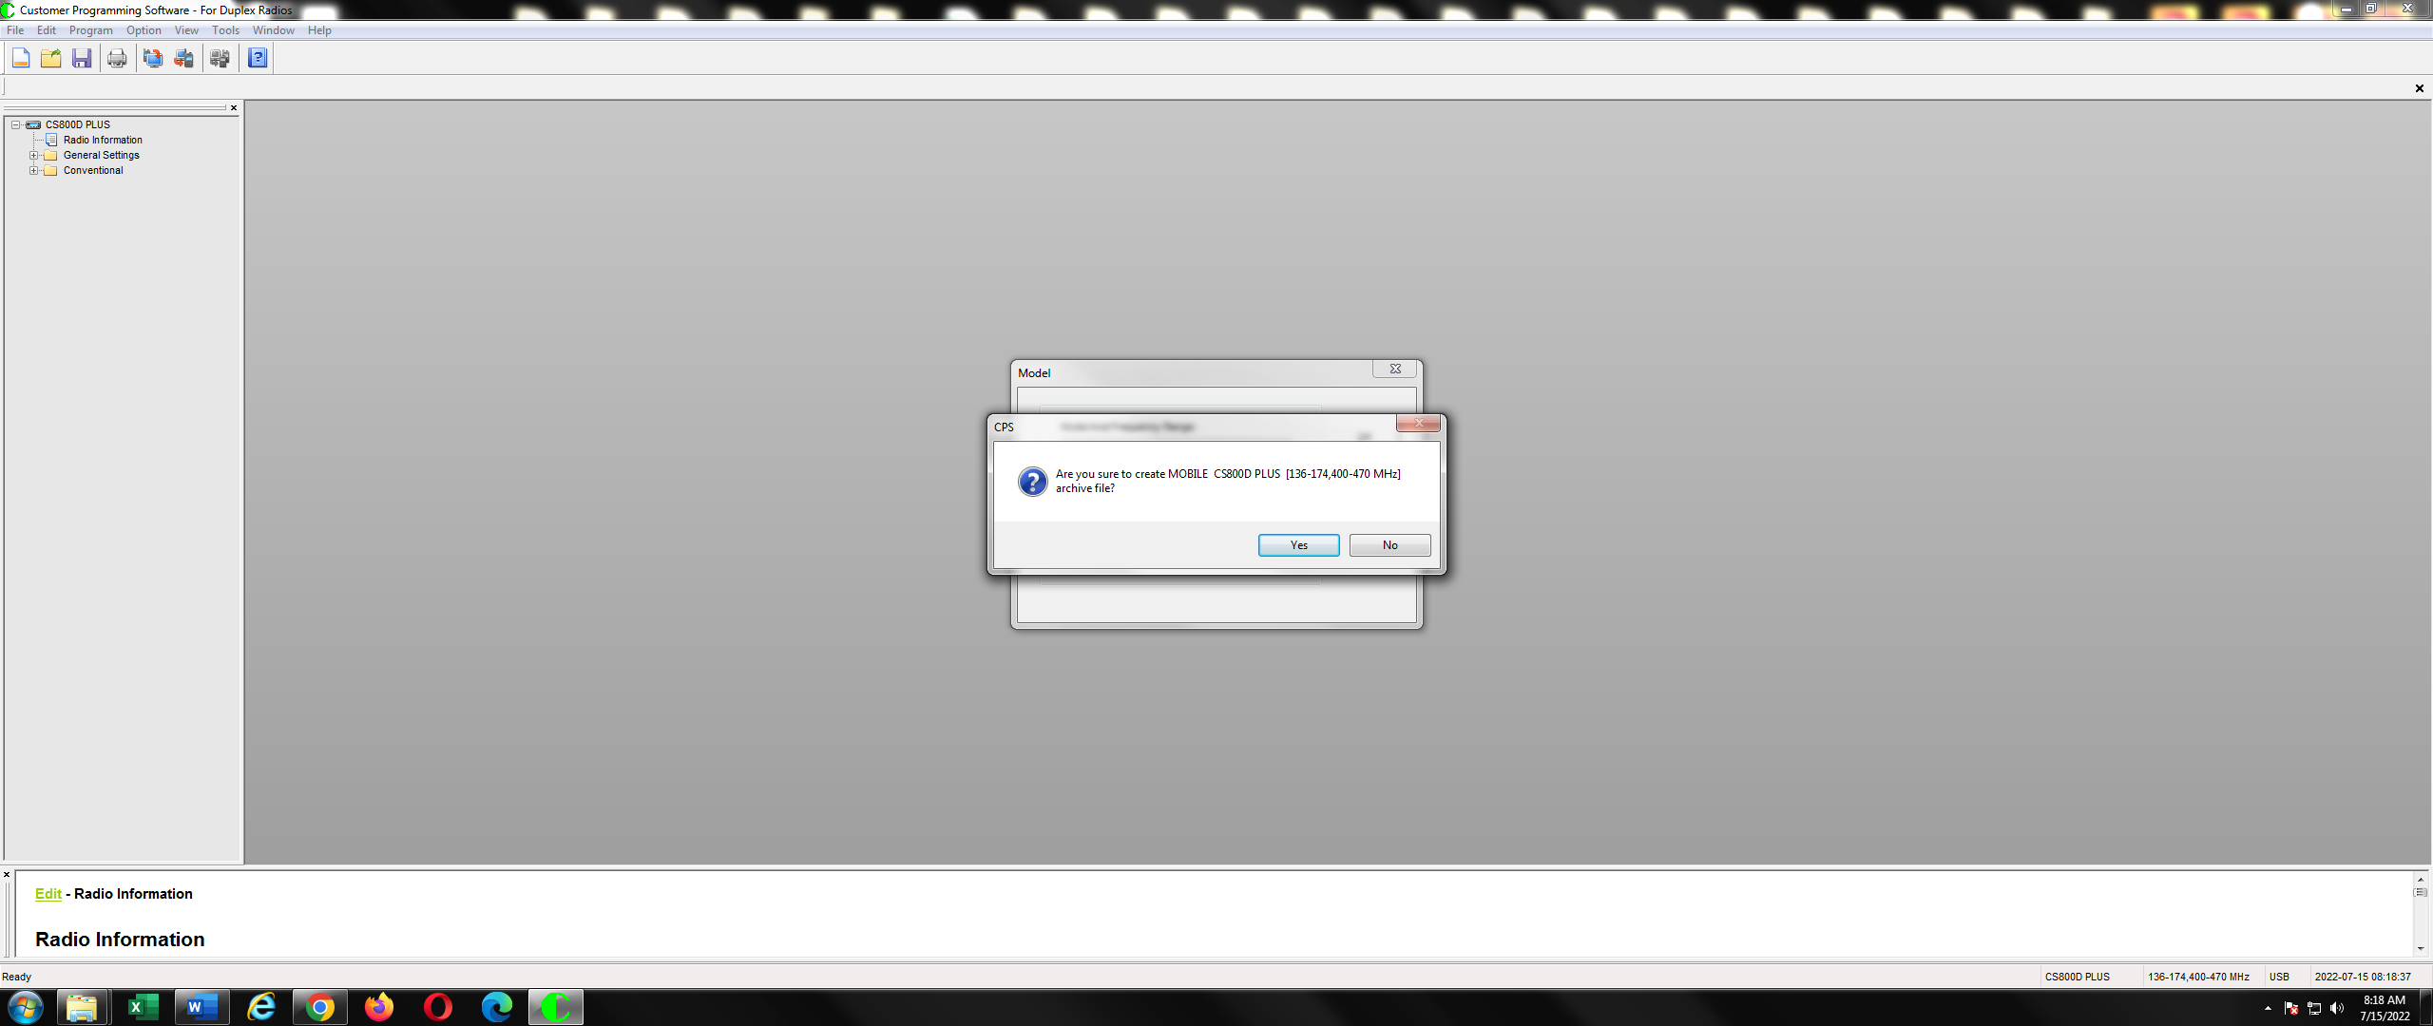
Then press the Yes key
If you selected the CS800D PLUS, you will get the following:
If you selected the CS800D, you will get the following:
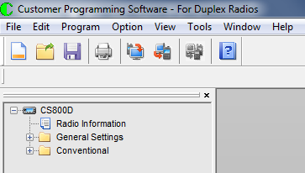
Alternatively, if you load in a new file through the “Open” command, the CPS will take the identity of the new file.

