CONVERTING A CODE PLUG FROM A CS800D TO A CS800D PLUS
To convert the code plug from your CS800D to your CS800D PLUS, open up your CPS with version R4.04.02 or later.
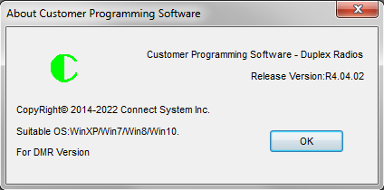
Then go to the tool section and select CPS Model Conversion.
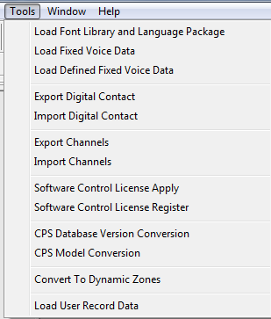
Select CS800D PLUS as the Target model.
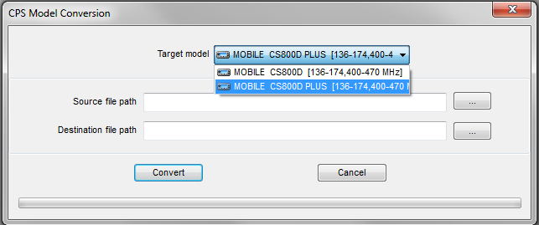

Press here to select file you want to convert.
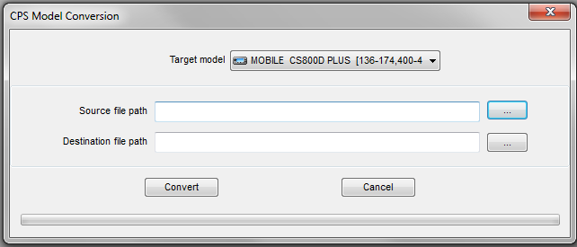
Select the file you want to convert.
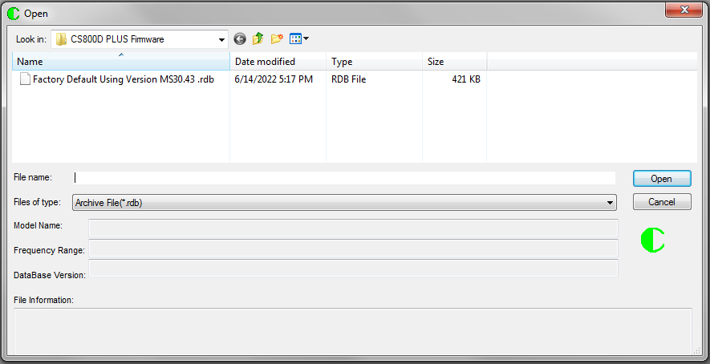
Press the Convert Key and you are finished.
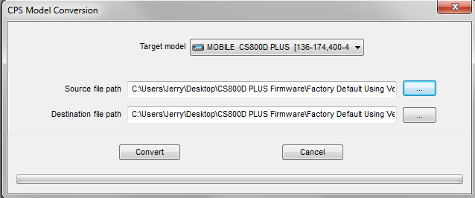

If Successful, you should get the following message.
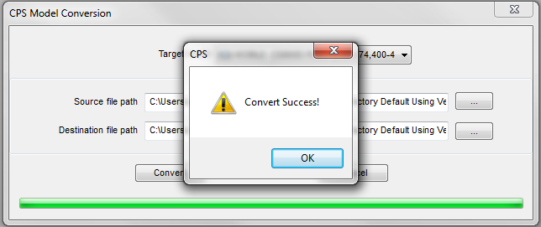
Notice that the program sets the new file to the same name in the same directory as the old file except it appends an 01 to the name.
