SETTING UP THE CPS
When you first start the CPS you are going to get the following screen (We will fix it in next version)
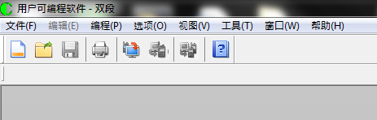
Press the (O) pull down menu and you get
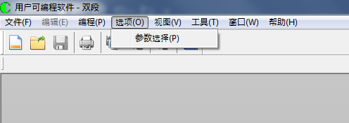
Press the (P) from the pulldown menu and you get
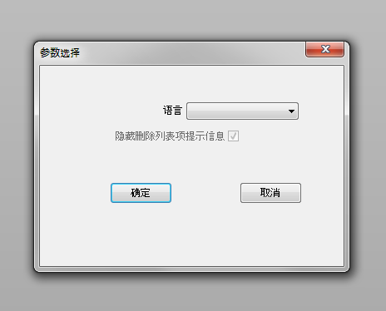
Select English as shown below and then press the button on the left (OK Key) to lock it in. The key on the right is the Cancel key.
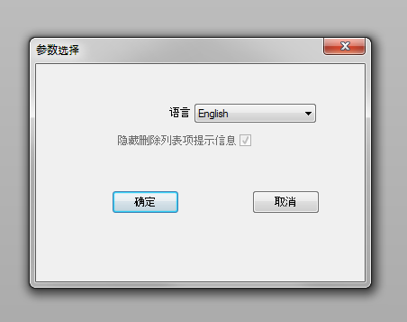

Now the menu looks as follows:
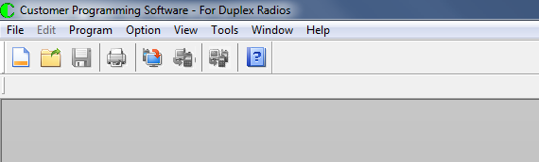
For those that prefer to use Mandarin Chinese, you can skip the above steps.

What Is New In The CPS
If you look at the buttons, you will see the following:
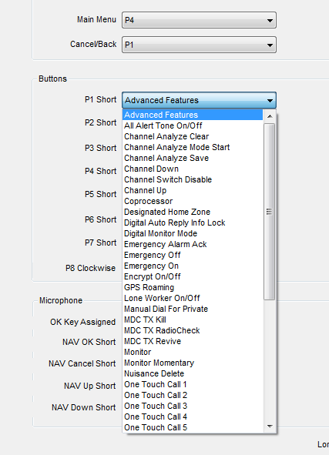
“Channel Analyze Clear”, “Channel Analyzer Mode Start” and “Channel Analyzer Save” are new button options.

If you look at the tool pulldown menu, you will see the following screen below:

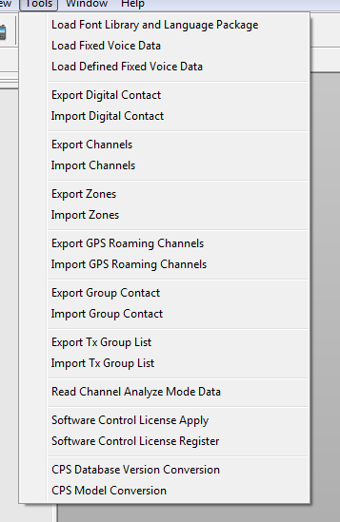
“Read Channel Analyze Mode Data” is new.

In the General Settings the “Channel Analyzer Mode” is new.
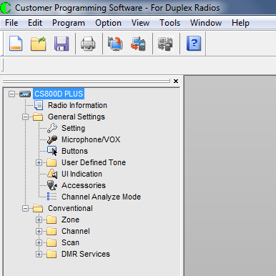

USING THE NEW FEATURE
- Set up the buttons as follows:
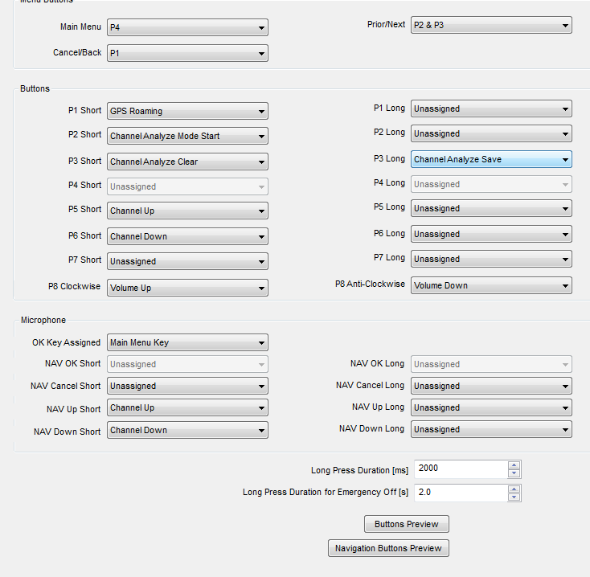

- Press the “Channel Analyzer Mode Start” button to start the program.
- Send CTCSS, DCS and DMR data to the Rx Frequency on the channel you are at.
- When you are ready to see what you have, Press the “Channel Analyzer Save” button to save the information to Flash Memory. Pressing the “Channel Analyzer Clear” button clears the information in the Flash Memory
- Open the CPS and in the Tool Section, press the “Read Channel Analyze Mode Data” to read the data from the radio.
- Press the “Channel Analyzer Mode” in the General Settings to look at the results as shown below.
