Using Front Panel Update Tool

The Front Panel Update Tool program is used for installing new firmware into the CS800D front panel.

**Step 1**First thing you need to do is download Front Panel Update Tool from our website. You can find the program at the following link:

<http://www.connectsystems.com/software/top/CS800D.htm>

The program you just downloaded is called FPUT.exe

**Step 2**Once you get the program, just run it and you should get the following:

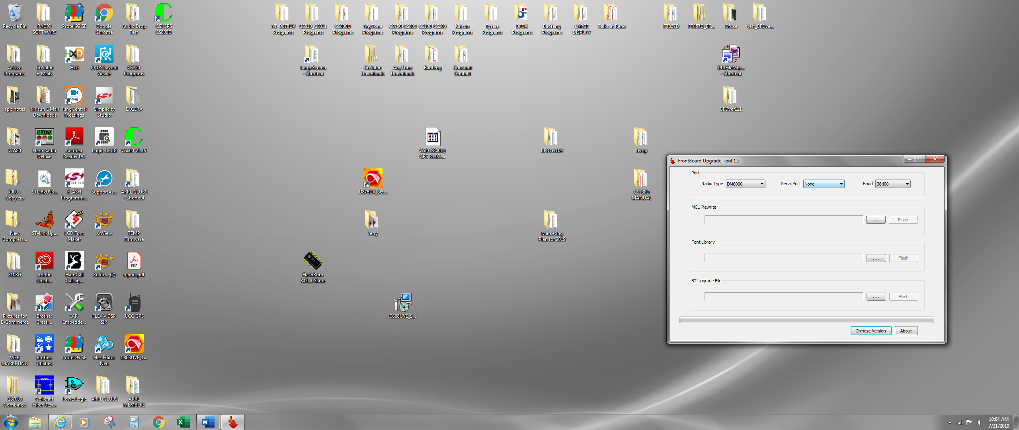

**Step 3**Now download the Front Panel Firmware Version 2.00.14 (zip) and unzip the file. The unzipped file name is:

FrontPanel_DM6000_V2.00.14.fot

Put it in the same directory as FPUT.exe

**Step 4**  
Attach the CS800D radio to a power supply and turn on the power supply. If the radio is turned on turn it off.

**Step 5**  
Attach the Programming cable between the RJ45 connector in the front of your radio and your USB port of the computer.

**Step 6**  
Press the P7 switch and while it is pressed turn on the power by pressing the power switch until the display says

Program  
 Mode

And the front panel LED is a solid red.

**Step 7**  
With your mouse left key, double click the button from the program you just ran that has three dots in the middle under the MCU Rewrite section.



You should get a window that looks similar to the one below.

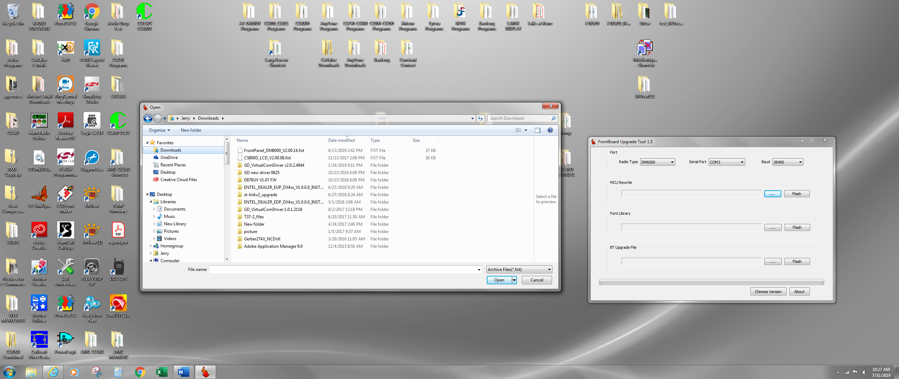

**Step 8**  
With the left key on your mouse, double click the line that says:

“FrontPanel_DM6000_V2--.14.fot”

The Front Panel Update Tool program should now look as follows:

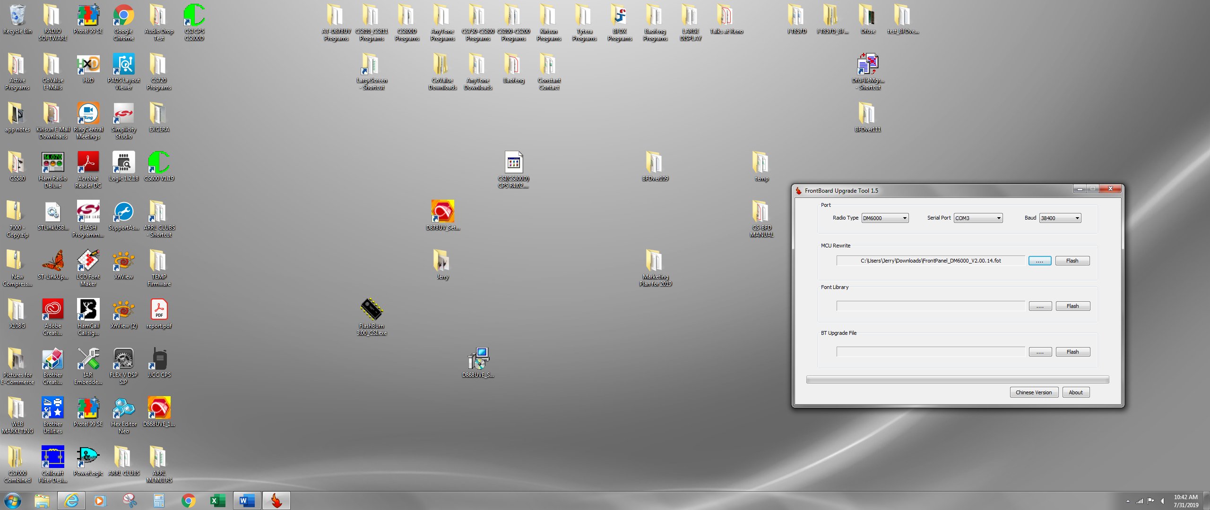

**Step 9**  
With the left key on your mouse, double click the button that says “Flash” just to the right of the line that was just inserted into the program.

The program should now look as follows:

When finished you should get the following message:

And the red led on the radio should turn off and the message on the screen should disappear. The radio is still on.

Press the power button for 10 seconds and then let go. The radio is now turned off.

You are finished!