**Direct Entry of Group Call and Private Call from Keypad**

From Settings Menu

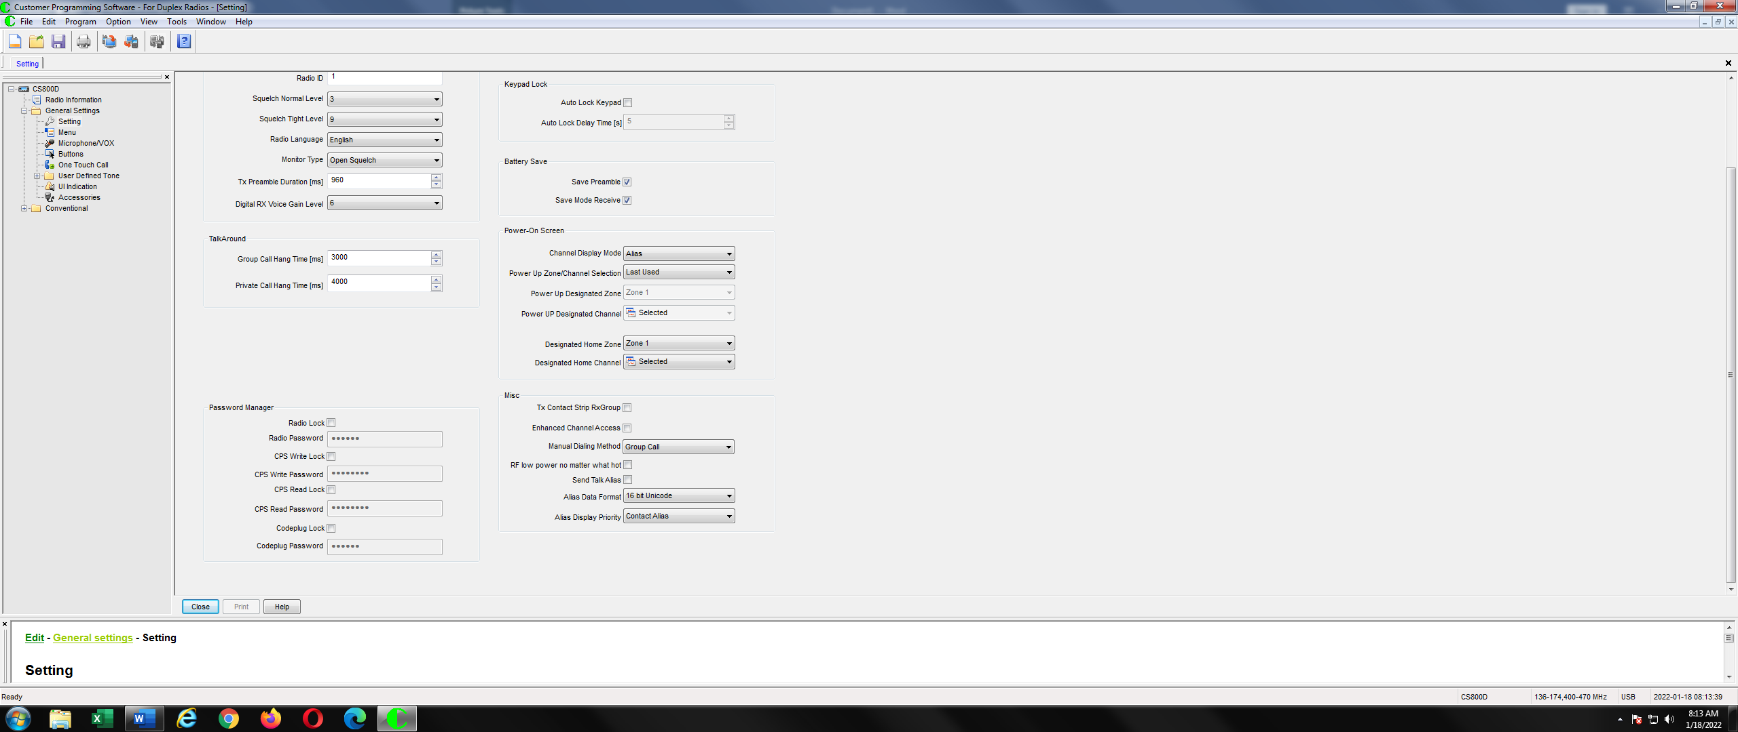

From Digital Channel Menu

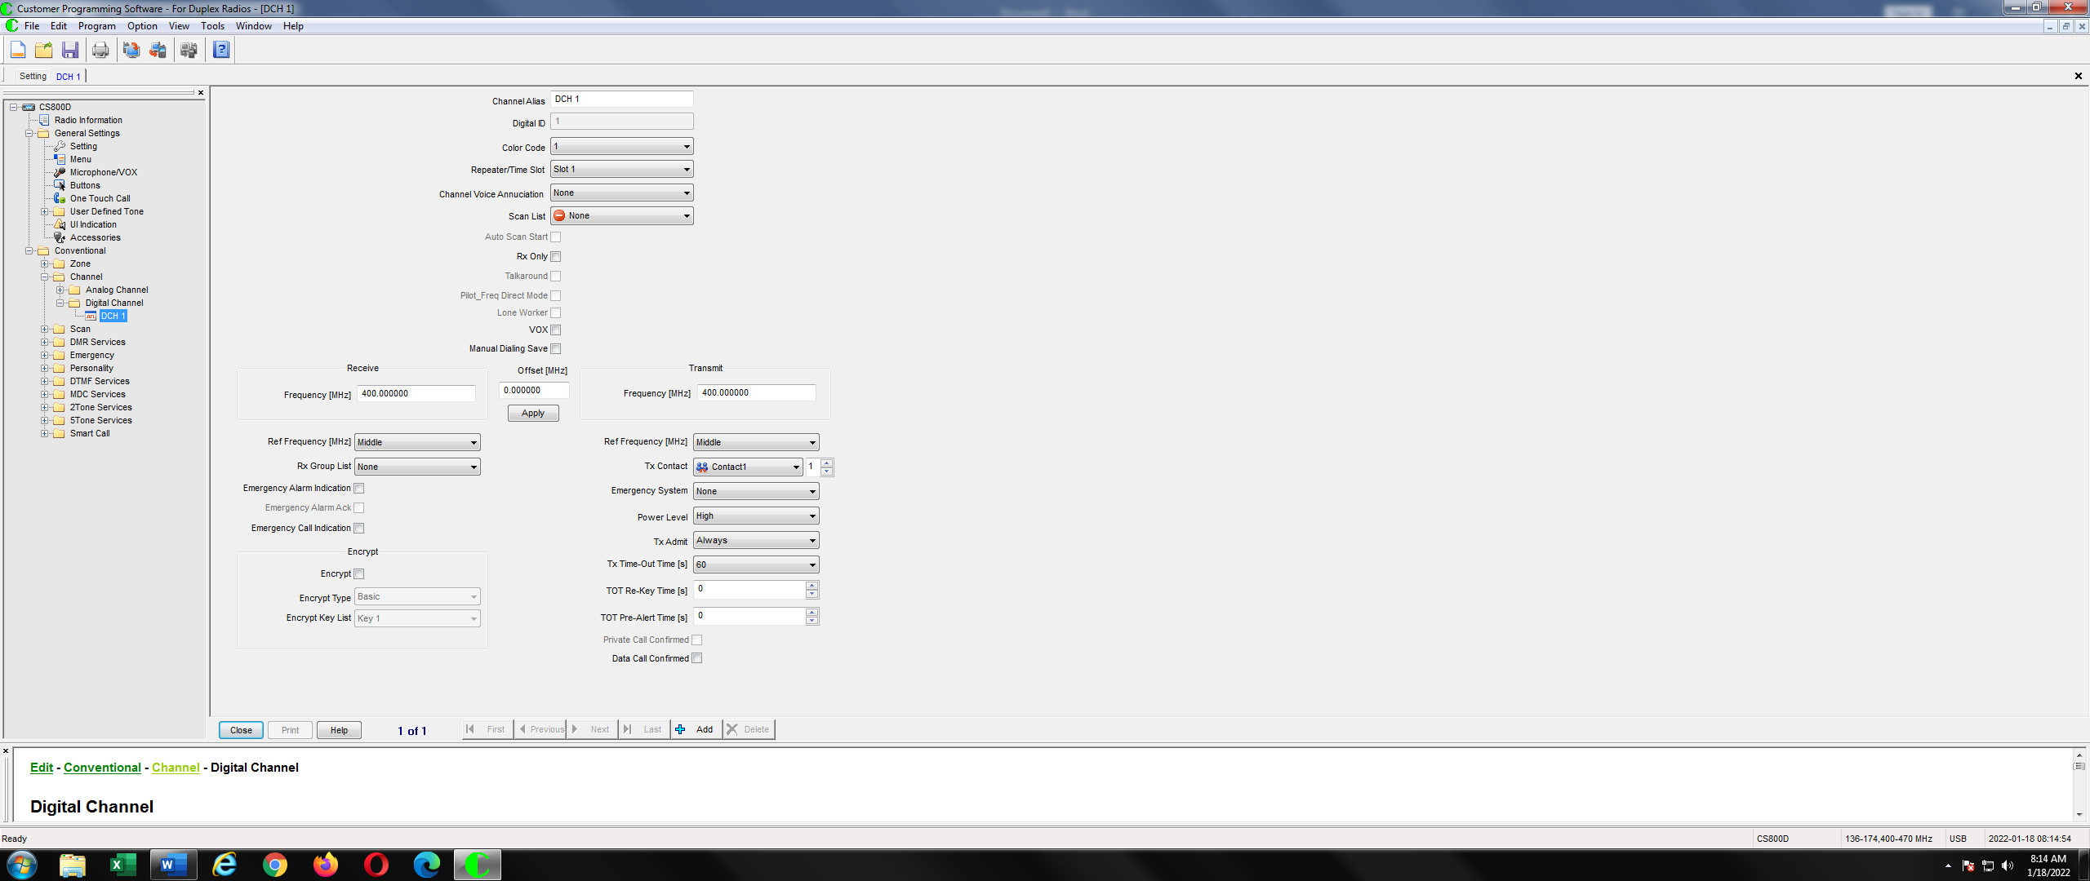

The above two parameters are used to set up the direct entry of the group calls and private calls from the microphone keypad.

**General Use of the two Parameters**

The manual dial method parameter can be set three ways.

1. Group Call
2. Private Call
3. Both

If you are only going to make group calls on the fly, then you should set it for Group Call. If you are only going to make private calls on the fly, then you should set it for Private Call. If you want to hedge your bets, then set it for both.

If you want to save your results even if you change channels or turn off the power, check the Manual Dialing Save check box. If you don’t want to permanently change the Tx Contact for that channel and want it to revert back to what was in the code plug, then do not check the Manual Dialing Save check box.

**Using it When Manual Dialing Method is set to Group Call**

To make a Group call, enter the Group call number from the microphone keypad as shown below.

Then Press the PTT and you are now making a Group call. The display while you are making the call is show below.

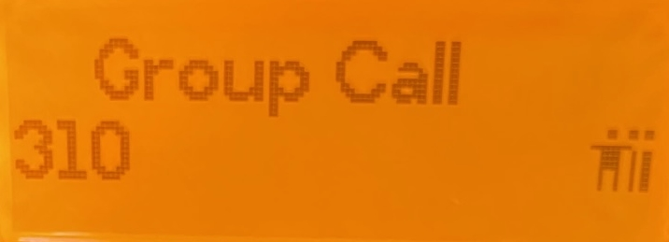

When you let go of the PTT and then push it again, the same display will come up showing that you are still making a group call to the number you entered.

If the Manual Dialing Save check box is unchecked, you will revert back to the call that is in your code plug if you change channels or you turn off the power.

If the Manual Dialing Save check box is checked, the group call will replace what was in the original code plug even if you change channels or turn off the power. If you read back the code plug from your radio, your code plug will show the new entry.

**Using it When Manual Dialing Method is set to Group Call**

To make a private call, enter the private call number from the microphone keypad as shown below.

Then Press the PTT and you are now making a private call. The display while you are making the call is show below.

When you let go of the PTT and then push it again, the same display will come up showing that you are still making a private call to the number you entered.

If the Manual Dialing Save check box is unchecked, you will revert back to the call that is in your code plug if you change channels or you turn off the power.

If the Manual Dialing Save check box is checked, the private call will replace what was in the original code plug even if you change channels or turn off the power. If you read back the code plug from your radio, your code plug will show the new entry.

**Using it When Manual Dialing Method is set to Both**

To make a Group call, enter the Group call number from the microphone keypad as shown below.

**Press the “O” key on the microphone keypad and you will get the following:**

If you don’t want to make a private call, press the “^” or “v” key from the microphone keypad to select the group call as shown on the next picture.

Now press the PTT to start speaking and you will be speaking on the group you just selected. The display will look as follows:



When you let go of the PTT and then push it again, the same display will come up showing that you are still making a group call to the number you entered.

If the Manual Dialing Save check box is unchecked, you will revert back to the call that is in your code plug if you change channels or you turn off the power.