**CS711-** Upgrade Test Guidance

1. When the radio is powered off, press and hold the PTT+TOP button to power on and enter the upgrade mode (the indicator light flashes red, green and orange alternately)
2. Use a USB writing cable to connect the walkie-talkie to the PC
3. Open the Firmware Upgrade Tool v8.1 tool
4. First, upgrade the Bootloader Version, and import the Bootloader Version that needs to be upgraded by clicking the [Select(*bin,*boot)] arrow as shown in the figure

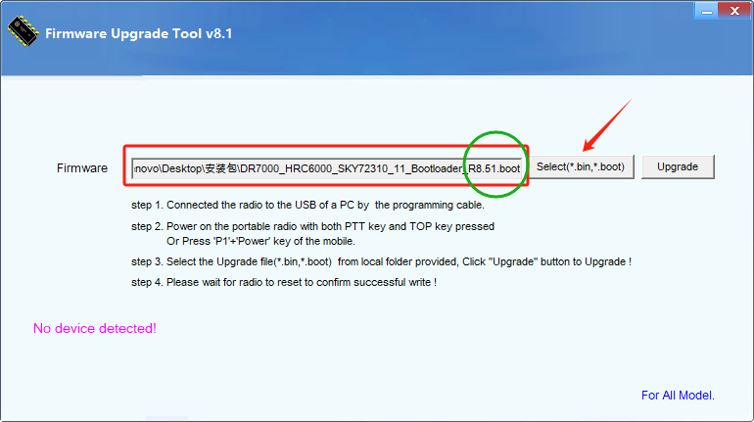

5. Click the [Update] arrow as shown in the figure to start the upgrade, and wait for the green progress bar to finish and then the pop-up window (Data transmitted successfully. Please wait for radio to reset to confirm successful write!).

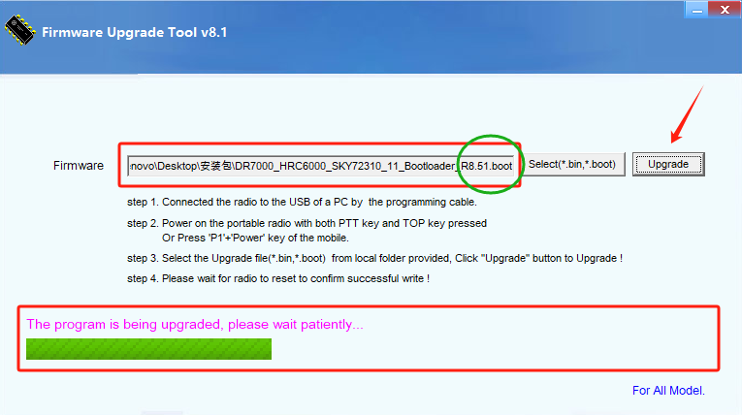

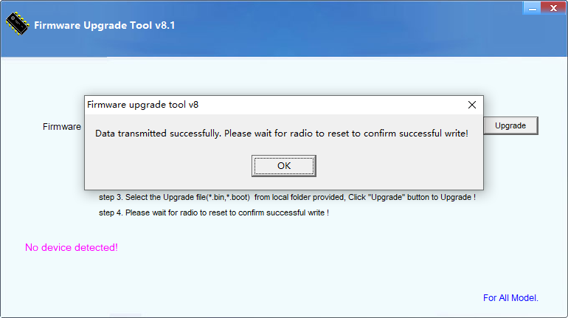

1. After the upgrade is successful, the machine will automatically restart, at this time, open CPS to read the machine data, click the arrow position as shown below after the reading is successful, and check that the [Bootloader Version] version is R8.51, that is, the Bootloader Version upgrade is successful

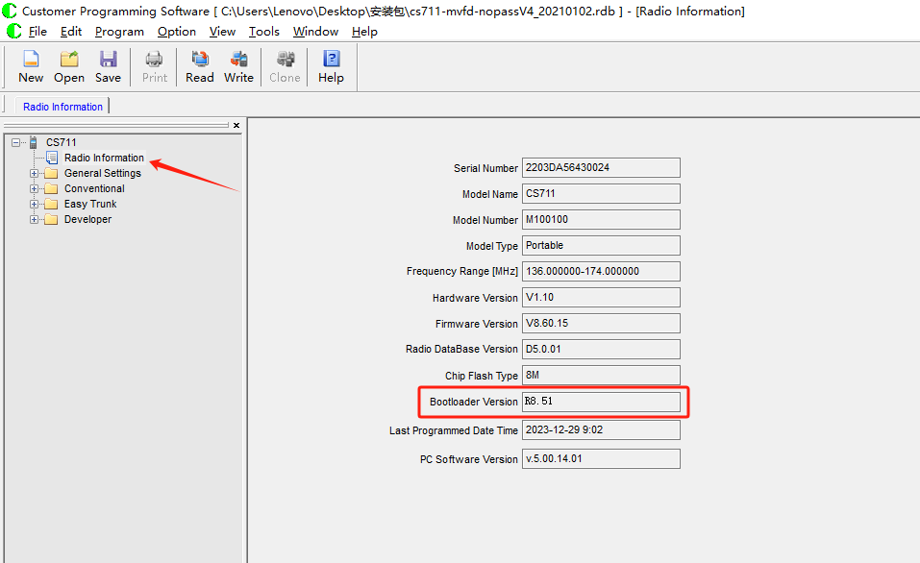

1. Repeat steps 1-3 to upgradeFirmware Version，will need to be upgradedFirmware Version如Click on the figure【Select（*bin，*boot）】The arrow position is imported in

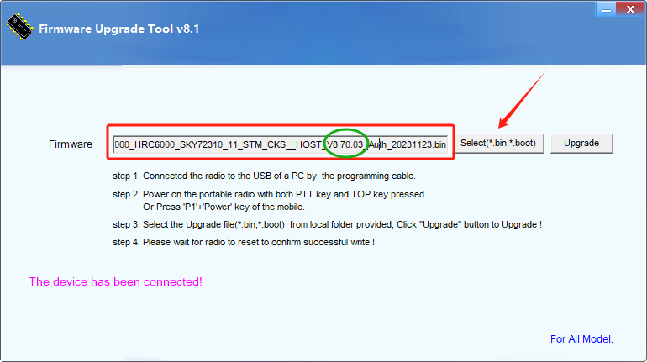

1. Click the [Update] arrow as shown in the figure to start the upgrade, and wait for the green progress bar to finish and the pop-up window will appear（Data transmitted successfully.Please wait for radio to reset to confirm successful write!）That is Firmware VersionThe upgrade was successful

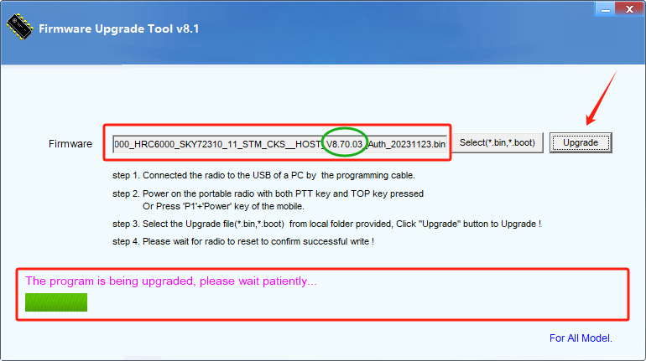

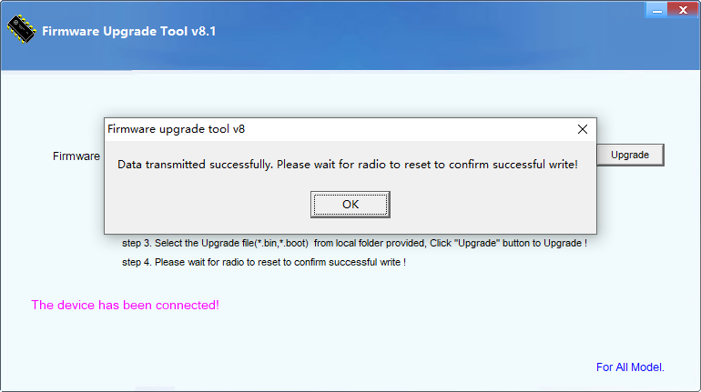

9、After the upgrade is successful, the machine will automatically restart, open CPS to read the machine data, click the arrow position as shown below after reading successfully, and check【Firmware Version】version V8.70.03That is Firmware VersionThe upgrade was successful

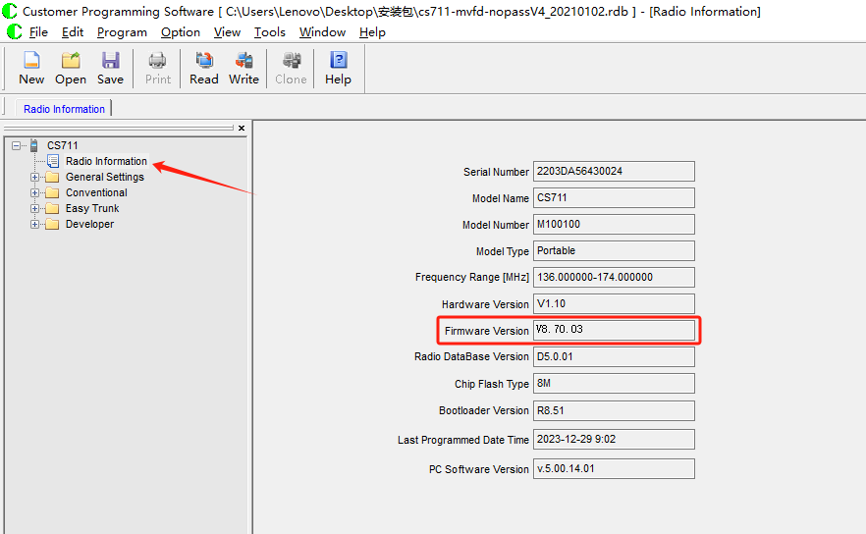

10、【Bootloader Version】和【Firmware Version】After the upgrade is successful, perform the following configurations:

