DR5810 Series CPS & Firmware Upgrade Guidelines (V1.0.2)
Preface:
DR5810/DR5610/DR5510/DR5100 need a special USB driver which is a little hard to be installed, in order to make it easy, the driver was combined into DR5810 series CPS installation. And then you could use the CPS to program a radio or the upgrading tools to upgrade a radio.
In other words, you need to install DR5810 CPS first. While installation, the special USB driver will be installed.

Install CPS
- Normally you just follow the Wizard of the CPS installer to install the CPS.
- Might need to pay attention to the following steps:
(Power up the Radio and connect it with the PC to let the PC find the USB Device!)
Must select the HR_C7000, then click Next button
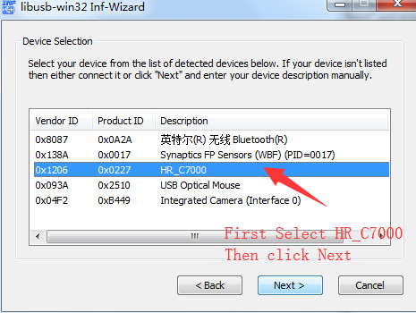

The installation information should be saved onto a file, including registry information etc. You just need to find a directory (such as “Default Data” directory of the CPS file or any other directory , to save it and please not delete it in the future.
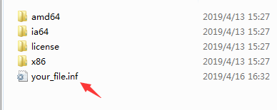
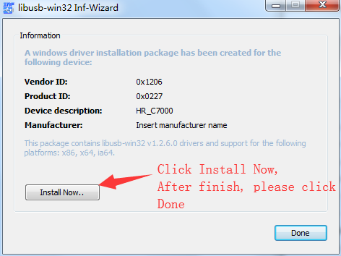
Install Upgrading Tool software
Run “HRC7000_DMR_FACTORY_DL_TOOLS_V1.01.01_Setup.exe” or above to install.

Upgrade software
Press the TOP Key & PTT then power on the radio to enter the upgrading mode, the LED will show RED/GREEN/ORANGE circularly.
Connect the programming cable with the computer.
Run the “Factory Flash Tool” and then load the files needed to upgrade you

. 